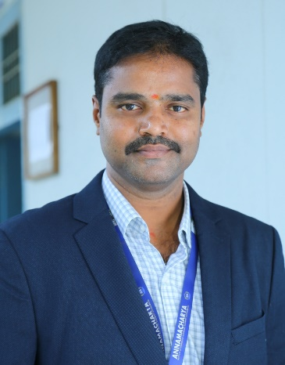

**Dr. T. Naresh Kumar**

**Associate Professor and Head**

***HoD’s Message:-***

**HEAD OF THE DEPARTMENT MESSAGE TO THE STUDENTS**

**Dear Prospective Students,**

As the Head of the Department of Civil Engineering at Annamacharya University, I am delighted to invite you to join our dynamic and thriving academic community. Our department is committed to shaping the future leaders of civil engineering, offering you an exceptional opportunity to engage in a program that combines rigorous academic training with innovative research and hands-on experience.

Since its establishment in 2012, our department has grown into a center of excellence, recognized for its forward-thinking approach to education and research. We offer comprehensive programs at the undergraduate, postgraduate, and doctoral levels, all designed to equip you with the knowledge, skills, and leadership qualities essential for addressing the most pressing challenges in civil engineering today.

Our faculty members are distinguished experts in their fields and are passionate about mentoring and guiding students. With state-of-the-art laboratories and active research in areas such as structural engineering, geotechnical engineering, transportation engineering, and environmental engineering and water resource engineering, you will have the chance to work on impactful projects that contribute to real-world solutions.

In addition to academic excellence, we emphasize practical learning through industry partnerships, consultancy projects, and hands-on problem-solving experiences. Our programs foster creativity, critical thinking, and a strong commitment to ethical and sustainable engineering practices.

Choosing the Department of Civil Engineering means choosing a pathway to a rewarding career that contributes to the betterment of society and the nation. I encourage you to explore the opportunities that await you here and to consider joining us on this exciting journey.

We look forward to welcoming you to our department and helping you build a successful future in civil engineering.

Warm regards,

**Dr T Naresh Kumar**  
Head of the Department of Civil Engineering  
Annamacharya University, Rajampet