**ANNAMACHARYA UNIVERSITY FACULTY DETAILS FOR WEBSITE**

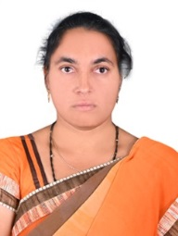**About Profile**

NAME: S.HASEENA

DATE OF BIRTH: 12-07-1989

DESIGNATION: ASSISTANT PROFESSOR

DEPARTMENT: MCA

EMAIL ID: haseenas@aitsrajampet.ac.in

DATE OF JOINING: 01-11-2022

EMPLOYEE ID: 1663

**Academic Profile**

| **Qualification** | **Name of the Board/University** | **YEAR** |
| --- | --- | --- |
| **MCA** | **Jawaharlal Nehru University Anantapur** | **2012** |
| **B.Sc** | **SV University** | **2009** |

**Research Details**

1. Areas of Specialization: -
2. List of Publications: 01
3. Awards Received : -
4. Research Guidance: -
5. No. of MCA Guided: 13
6. Details of Professional Membership: -
7. Subjects Taught: Social Network Analysis,

Introduction to Python Programming Language

**Publication Details**

|  |  |  |
| --- | --- | --- |
| **Title** | **Publisher** | **Published Year** |
| Towards Precise Peach Disease Detection: Leveraging PCNN with Enhanced Activation and AFHOA Fine-Tuning | 2024 Asian Conference on Intelligent Technologies (ACOIT) | Septermber 2024 |