**ANNAMACHARYA UNIVERSITY FACULTY DETAILS FOR WEBSITE**

**About Profile**

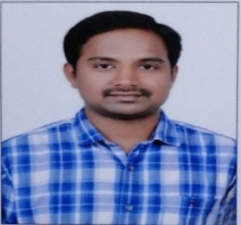

NAME: S.THABREEZ BASHA

DATE OF BIRTH: 10-06-1986

DESIGNATION: ASSISTANT PROFESSOR

DEPARTMENT: MCA

EMAIL ID: thabreez.basha154@gmail.com

DATE OF JOINING: 14-06-2023

EMPLOYEE ID: 1706

## Academic Profile

| **Qualification** | **Name of the Board/University** | **YEAR** |
| --- | --- | --- |
| **MCA** | **OSMANIA UNIVERSITY** | **2011** |
| **DEGREE** | **S.V UNIVERSITY** | **2007** |

Research Details

1. Areas of Specialization:
2. List of Publications:
3. Awards Received :
4. Research Guidance:
5. No. of MCA Guided: 13
6. Details of Professional Membership:
7. Subjects Taught: Computer Organization, Web Technologies, Operating Systems and Universal Human Values

## Publication Details

|  |  |  |
| --- | --- | --- |
| **Title** | **Publisher** | **Published Year** |
|  |  |  |

## Patent Details

| **Sno.** | **Title of Patent** | **Submitted/Published/Awarded** |
| --- | --- | --- |
|  |  |  |
|  |  |  |