**ANNAMACHARYA UNIVERSITY FACULTY DETAILS FOR WEBSITE**

**About Profile**

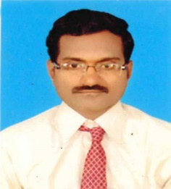

NAME: D. SIVASANJEEV KUMAR

DATE OF BIRTH: 20 -08 - 1980

DESIGNATION: Assistant Professor

DEPARTMENT: MCA

EMAIL ID: kumar.sivasanjeev@gmail.com

DATE OF JOINING: 26 -07 - 2024

EMPLOYEE ID: 1798

## Academic Profile

| **Qualification** | **Name of the Board/University** | **YEAR** |
| --- | --- | --- |
| Ph.d(pursuing) | Annamacharya University | - |
| M.C.A | Jawaharlal Nehru Technological University Hyderabad (JNTH) | 2006 |
| Degree ( BSC Computers) | S.V. University | 2002 |

## Research Details

1. Areas of Specialization:
2. List of Publications:
3. Awards Received :
4. Research Guidance:
5. No. of PhD Guided:
6. No. of M.Tech Guided:
7. No. of B.Tech Guided:
8. Details of Professional Membership:
9. Subjects Taught: Object Oriented Modeling and Design With UML

|  |  |  |
| --- | --- | --- |
| **Title** | **Publisher** | **Published Year** |
|  |  |  |

## Publication Details

## Patent Details

| **Sno.** | **Title of Patent** | **Submitted/Published/Awarded** |
| --- | --- | --- |
|  |  |  |
|  |  |  |