**ANNAMACHARYA UNIVERSITY FACULTY DETAILS FOR WEBSITE**

**About Profile**

NAME: P. KAVITHA

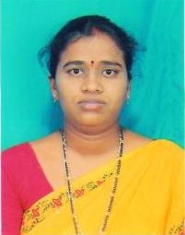

DATE OF BIRTH: 14-11-1980

DESIGNATION: ASSISTANT PROFESSOR

DEPARTMENT: MCA

EMAIL ID: paletigandlakavitha@gmail.com

DATE OF JOINING: 17-06-2007

EMPLOYEE ID: 354

## Academic Profile

| **Qualification** | **Name of the Board/University** | **YEAR** |
| --- | --- | --- |
| **Ph.D (Computer Science)** | **Annamacharya University** | **Pursuing** |
| **M.Tech(CSE)** | **JNTUA** | **2016** |
| **MSC(IS)** | **Osmania University** | **2004** |

Research Details

1. Areas of Specialization: Software Engineering
2. List of Publications:
3. Awards Received : NIL
4. Research Guidance:
5. No. of PhD Guided:
6. No. of M.Tech Guided:
7. No.of MCA Guided: 24
8. No. of B.Tech Guided:
9. Details of Professional Membership :
10. Subjects Taught: Software Engineering, Web Technologies

## Publication Details

|  |  |  |
| --- | --- | --- |
| **Title** | **Publisher** | **Published Year** |
| 1. Performance Assessment of CPU Scheduling Algorithms: A Scenario – Based Approach with FCFS,RR and SJF. | The Bioscam | July 2024 |
| 1. Computer Vision for Reducing Food Waste in Institutional Canteen: A Literature Review and Performance Analysis. | Industrial Engineering Journal | October 2023 |

| **Sno.** | **Title of Patent** | **Submitted/Published/Awarded** |
| --- | --- | --- |
|  |  |  |
|  |  |  |

## Patent Details