**ANNAMACHARYA UNIVERSITY FACULTY DETAILS FOR WEBSITE**

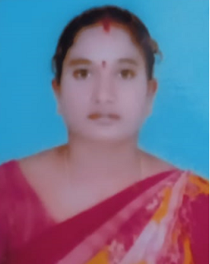**About Profile**

NAME: B.BUJJI

DATE OF BIRTH: 10-07-1990

DESIGNATION: ASSISTANT PROFESSOR

DEPARTMENT: MCA

EMAIL ID: [bujjinukala86@gmail.com](mailto:bujjinukala86@gmail.com)

DATE OF JOINING: 01-03-2021

EMPLOYEE ID: 2041

**Academic Profile**

| **Qualification** | **Name of the Board/University** | **YEAR** |
| --- | --- | --- |
| **MSc** | **Y V University Kadapa** | **2013** |
| **B.Com** | **Y V University Kadapa** | **2011** |

**Research Details**

1. Areas of Specialization: -
2. List of Publications: -
3. Awards Received : -
4. Research Guidance: -
5. No. of MCA Guided: -
6. Details of Professional Membership: -
7. Subjects Taught: Software Engineering, Constitution of India

**Publication Details**

|  |  |  |
| --- | --- | --- |
| **Title** | **Publisher** | **Published Year** |
|  |  |  |