**ANNAMACHARYA UNIVERSITY FACULTY DETAILS FOR WEBSITE**

**About Profile**

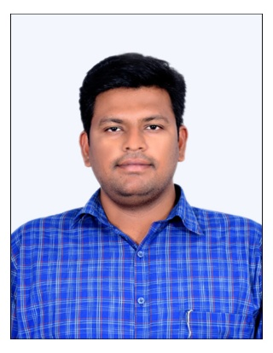

NAME: **SHAIK ASHRAF ALI**

DATE OF BIRTH:  **08/09/1994** DESIGNATION:  **ASSISTANT PROFESSOR** DEPARTMENT**: CIVIL ENGINEERING**

EMAIL ID: **shehnaazali1311@gmail.com**

DATE OF JOINING: **26/09/2021**

EMPLOYEE ID: **AITS_01**_**1583**

## Academic Profile

| **Qualification** | **Name of the Board/University** | **YEAR** |
| --- | --- | --- |
| **Master of Technology (**Structural**)** | Annamacharya Institute of Technology & Sciences, Rajampet | **2021** |
| **Bachelor of Technology** | Annamacharya Institute of Technology & Sciences, Rajampet | **2017** |
| **Intermediate** | Sri Nalanda Junior College | **2013** |

## Research Details

1. Areas of Specialization: Structural Engineering
2. No. of Publications: 02
3. Awards Received : Nill
4. Research Guidance:
5. No. of PhD Guided: -
6. No. of M.Tech Guided: -
7. No. of B.Tech Guided: 13
8. Details of Professional Membership:
9. Subjects Taught: Strength of Materials, Design of Steel Structures, Engineering Geology, Soil Mechanics, Environmental Impact Assessment & life Cycle Assessment, Disaster Management.

## Publication Detail

|  |  |  |
| --- | --- | --- |
| **Title** | **Publisher** | **Published Year** |
| Studies of Concrete with Partial Replacement of Cement by Combination of Seashell Powder, Fly Ash and GGBS | **PENSEE International** | 2021 |
| A Comprehensive Study on Significance of Optimization Algorithms Applied In various Fields for better Results | **Springer** | 2025 |

## Patent Details:

| **Sno.** | **Title of Patent** | **Submitted/Published/Awarded** |
| --- | --- | --- |
|  |  |  |
|  |  |  |