Resume

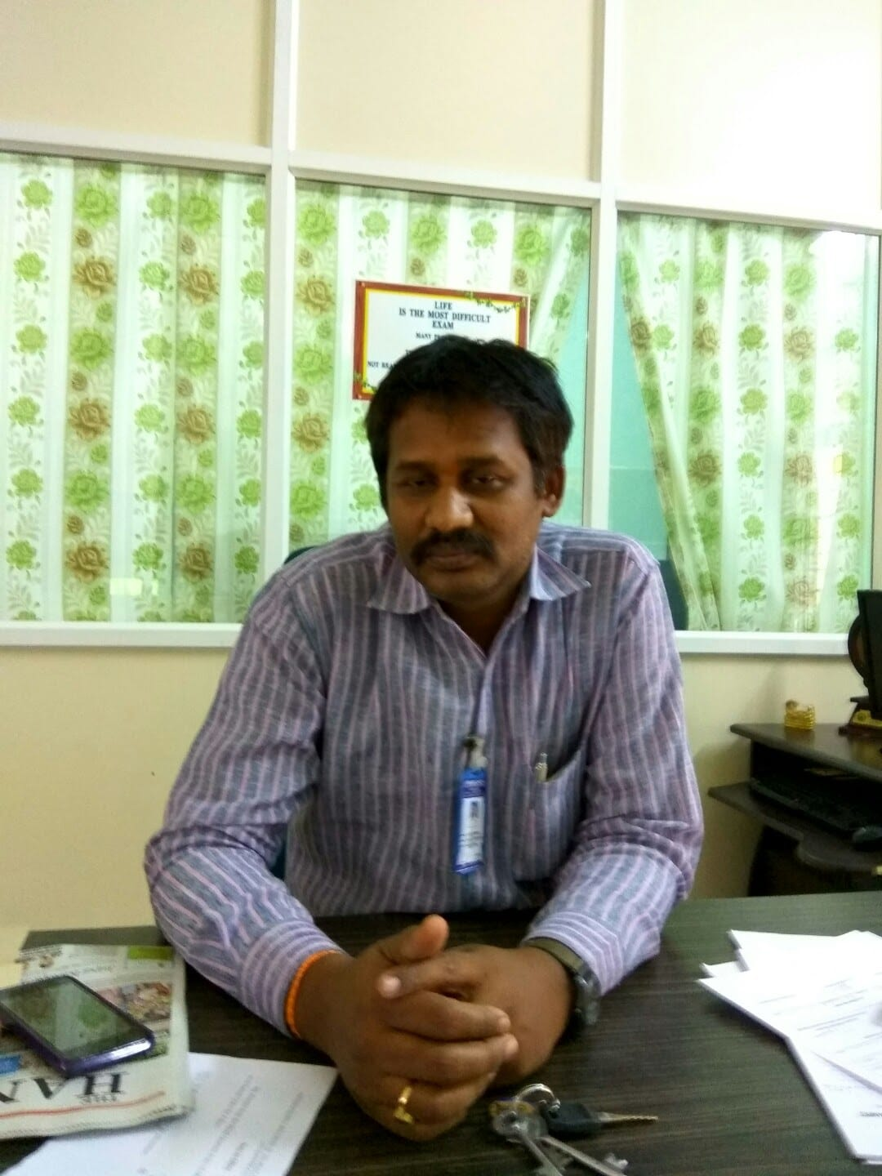
Mr.M.Maruthi Prasad
Controller of Examinations
Annamacharya University
Rajampet
Email: coe@aitsrajampet.ac.in
Mobile: 94404 75635, 9848998647

Teaching Experience

- 23 years of teaching experience at Engineering College UG & PG Level.

Professional Background

- Worked as an Assistant Professor at Mandsaur Institute of Technology & Scinces, Mandsaur from 1st October 2002-1st September 2004.

- Worked as an Assistant Professor at Swami Vivekananda College of Engineering. Indore from 2nd September 2004 to 27th June 2005.

- Worked as an Assistant Professor at AVS College of Engineering & Technology, Nellore from 1st July 2005 to 25th September 2006.

- Worked as an Assistant Professor at Annamacharya Institute of Technology & Sciences, Rajampet from 26th September 2006 to 31st July 2012.

- Presently working as Associate Professor at Annamacharya Institute of Technology & Sciences, Rajampet from 1st August 2012 to till date.

Educational Qualification

- Master of Engineering (Tribology & Maintenance Engineering) Degree from SGSITS, Indore during the year 2002 and passed in First class with distinction.

- Bachelor of Technology (Mechanical Engineering) Degree from Kakatiya Institute of Technology & sciences, Warangal during the year 2000 and passed in First class.

- Diploma (Mechanical Engineering) from GMR Polytechnic, Srisailam in the year 1995 with First class.

- Passed 10th Class from Govt. High School, Rayachoti during the year 1992 in First class.

Academic Responsibilities

- Presently Working as Controller of Examinations from 1st December 2015.
- College Sports council member since 2009.

- Department coordinator for National Board Accreditation (NBA) two times (2009 & 2011).

- Department coordinator for National Assessment and Accreditation Council (NAAC-2010).

- Academic Council Member at Annamacharya Institute of Technology & Sciences, Rajampet.

Field of Specialization: Machine Design.

Paper Publications

Participated in various National/ Conferences/Seminars/Workshops and published papers in reputed international journals as listed below.

- National Conferences : 05
- National Workshops : 10
- International Conferences : 04
- International Journals : 07

Subjects taught for UG Level

- Engineering Mechanics
- Mechanics of Solids
- Design of Machine Elements-I & II
- Engineering Drawing
- Tribology
- Non-Conventional Sources of Energy

Subjects taught for PG Level
- Vibrations & Stress Analysis
Number of projects guided
B.Tech : 20
M.Tech : 09

Title of Research work : Implementation of Axiomatic Design & TIPS to enhance production performance of Cellular Manufacturing System.

