**ANNAMACHARYA UNIVERSITY FACULTY DETAILS FOR WEBSITE**

**About Profile**

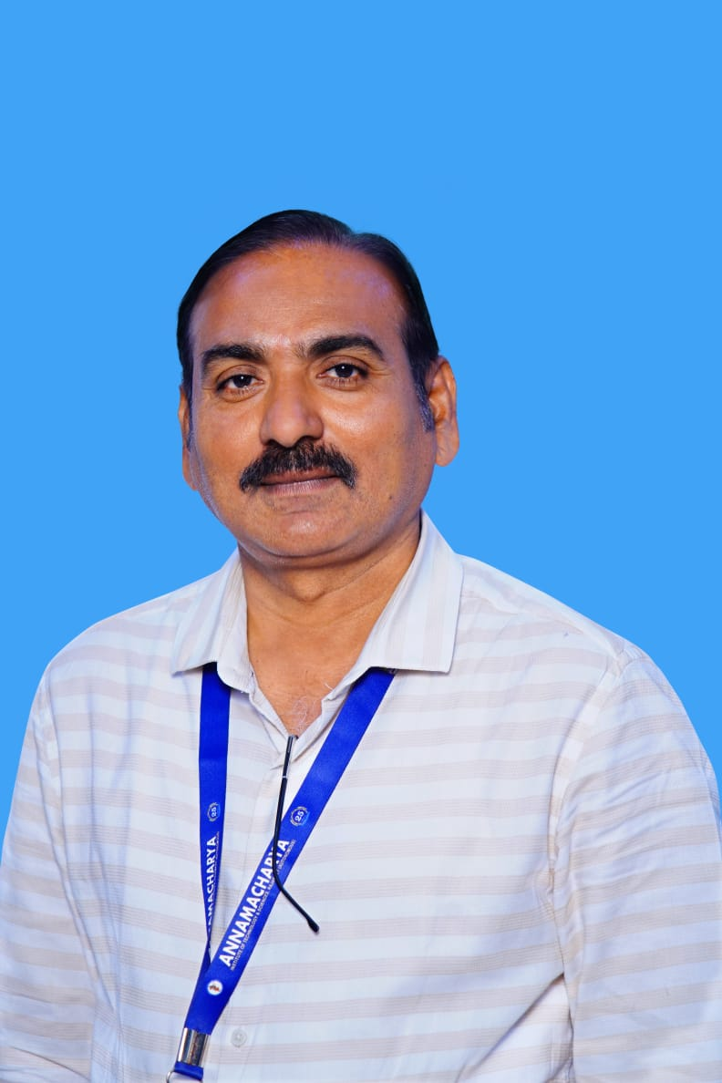

NAME: **Dr. CH. NAGARAJU**

DATE OF BIRTH: **05-05-1977**

DESIGNATION: **Professor & Head**

DEPARTMENT: **ECE**

EMAIL ID: [chrajuaits@gmail.com](mailto:chrajuaits@gmail.com), [chn@aitsrajampet.ac.in](mailto:chn@aitsrajampet.ac.in)

DATE OF JOINING: **02-09-2011**  EMPLOYEE ID: **AITS041004**

## Academic Profile

|  |  |  |
| --- | --- | --- |
| **Qualification** | **Name of the Board/University** | **YEAR** |
| Ph.D | SunRise University, Alwar, Rajasthan | 2016 |
| M.Tech | SKU, Anantapur | 2005 |
| B.Tech | JNTU, Hyderabad | 2002 |

## Research Details

1. **Areas of Specialization**: Wireless Communications & Networks

1. **List of Publications**: 50

Journals: 20, Conferences: 17, Books / Book Chapters: 13

1. **Awards Received**: 06
2. **Research Guidance:**
3. No. of Ph.D Guided: **03** (Guiding)
4. No. of M.Tech Guided: **20**
5. No. of B.Tech Guided: **38**
6. **Details of Professional Membership:**

* **AMIEI**
* **MIAENG**

1. **Subjects Taught:**

Wireless Communication Networks, Cellular Mobile Communications, Optical Fiber Communication, Analog Communication, Digital Communication, Electronic Devices and Circuits, Electronic Circuit Analysis

## Publication Details

|  |  |  |  |
| --- | --- | --- | --- |
| **S.No.** | **Title** | **Publisher** | **Published Year** |
|  | Cardiac Diagnosis System For Heart Diseases Classification Based on Deep Learning and Optimization Strategies Using ECG Signals | IEEE | 2025 |
|  | Hybrid optimization algorithm for enhanced performance and security of counter-flow shell and tube heat exchangers | PLOS ONE | 2024 |
|  | A hybrid model for lung cancer prediction using patch processing and Deep learning on CT images. | Springer Nature | 2024 |
|  | Influence of performance and emission of diesel engine with alumina nano material-based catalyst biodiesel using IoT | IJPEC | 2024 |
|  | Detection and Classification of COVID-19 Using Supervised Deep Learning on MRI Images | IJMEI | 2023 |

## Patent Details

| **S. No.** | **Title of Patent** | **Submitted/Published/Awarded** |
| --- | --- | --- |
|  | IoT System to Detect and Analyze Gait of an Individual and Method Employed Thereof | Published |
|  | Computer Implemented Method and System for Processing Qualitative Imaging to Detect and Forecast Abnormalities | Published |