**About Profile**

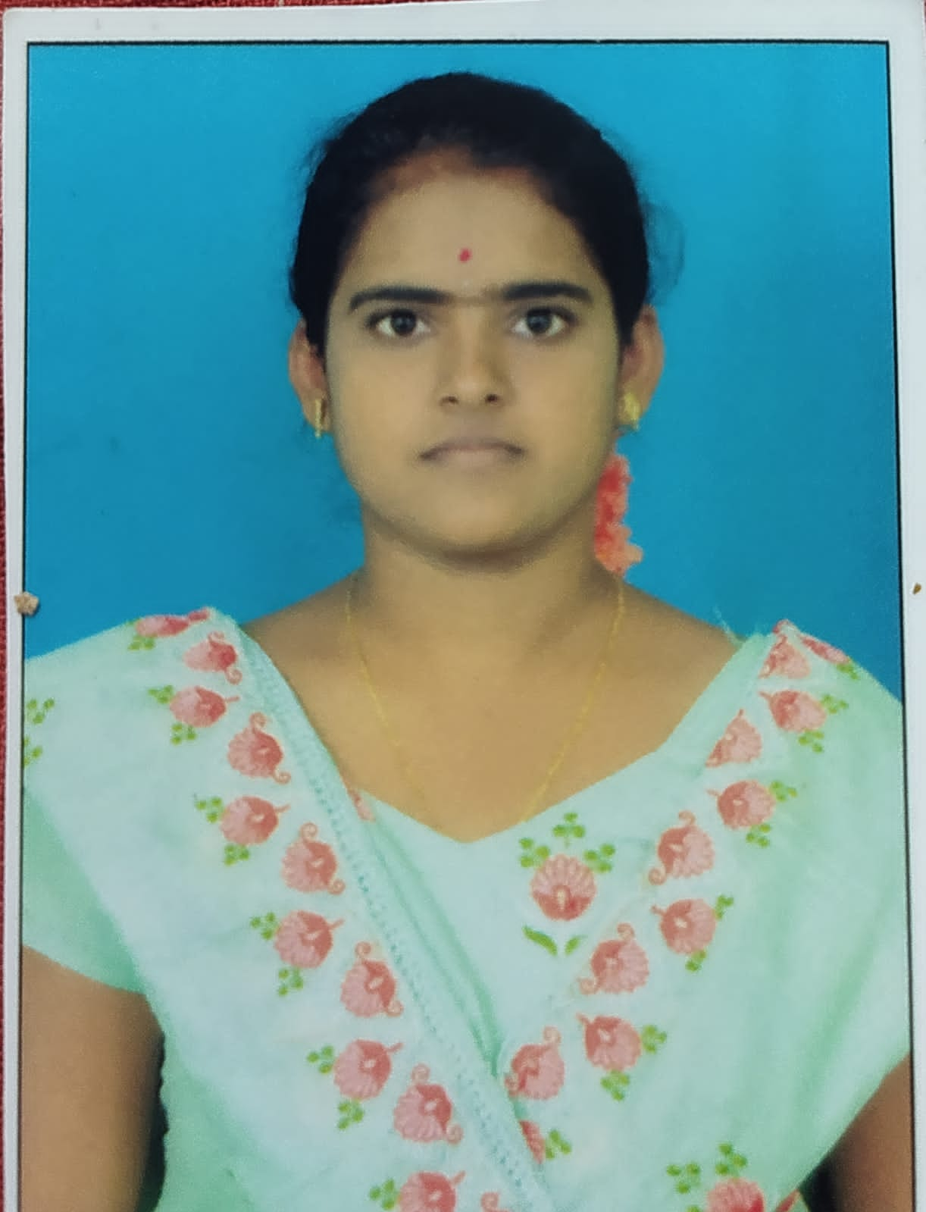

NAME: S. Prasanna

DATE OF BIRTH: **10/06/2001**

DESIGNATION: **Assistant Professor**

DEPARTMENT: **AI&DS**

EMAIL ID: **sanapalleprasanna@gmail.com**

DATE OF JOINING: **03/10/2023**

EMPLOYEE ID:1733

## Academic Profile

| **Qualification** | **Name of the Board/University** | **YEAR** |
| --- | --- | --- |
| **MCA** | **JNTUA, Anantapur** | **2023** |
| **Degree** | **YVU, KADAPA** | **2021** |
| **Inter** | **State Board** | **2018** |
| **SSC** | **State Board** | **2016** |

## Research Details

1. Areas of Specialization: NIL
2. List of Publications: 2
3. Awards Received: **NIL**
4. Research Guidance:
5. No. of PhD Guided: **NIL**
6. No. of MTech Guided: **NIL**
7. No. of B. Tech Guided: **02**
8. Details of Professional Membership: **NIL**
9. Subjects Taught:

* **Introduction to Programming**
* **Software Engineering**
* **Computer organization and architecture**

## Publication Details

|  |  |  |
| --- | --- | --- |
| **Title** | **Publisher** | **Published Year** |
| Applications and Advancement of Nanoparticle -Based Drug Delivery in Lung Cancer Treatment | IEEE | April 2025 |
| Traffic-Flow Predictor: Predicting Traffic Volume and Patterns | IEEE | May 2025 |