**ANNAMACHARYA UNIVERSITY FACULTY DETAILS FOR WEBSITE**

**About Profile**

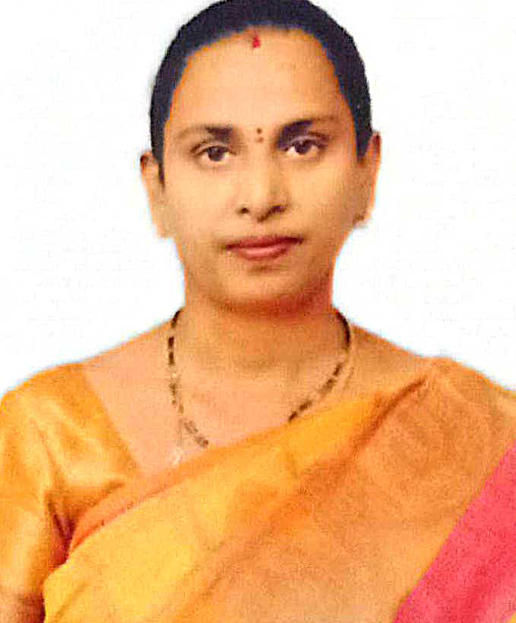

NAME: Dr. M. PARVATHI

DATE OF BIRTH: 16\08\1983

DESIGNATION: ASSISTANT PROFESSOR

DEPARTMENT: HUMANITIES AND SCIENCES

EMAIL ID: [parvathimeruva06@gmail.com](mailto:parvathimeruva06@gmail.com)

DATE OF JOINING: 19/8/2013

EMPLOYEE ID: AITS991019

## Academic Profile

| **Qualification** | **Name of the Board/University** | **YEAR** |
| --- | --- | --- |
| **Ph.D** | **Sri Padmavathi Mahila Visvavidyalayam, Tirupathi** | **2020** |
| **M.sc** | **Sri Padmavathi Mahila Visvavidyalayam, Tirupathi** | **2005** |
| **B.Sc** | **S.V.University, Tirupathi** | **2003** |

## Research Details

1. Areas of Specialization: Fluid Mechanics
2. List of Publications: 14
3. Awards Received : Nil
4. Research Guidance:
5. No. of PhD Guided: Nil
6. No. of M.Tech Guided: Nil
7. No. of B.Tech Guided: Nil
8. Details of Professional Membership: Nil
9. Subjects Taught: Algebra & Calculus,

Differential Equations and Transform Techniques,

Probability & Statistics,

Discrete Mathematics,

Mathematical Foundation of Computer Science,

Complex analysis.

## Publication Details

|  |  |  |
| --- | --- | --- |
| **Title** | **Publisher** | **Published Year** |
|  |  |  |

## Patent Details

| **Sno.** | **Title of Patent** | **Submitted/Published/Awarded** |
| --- | --- | --- |
|  |  |  |
|  |  |  |