**About Profile**

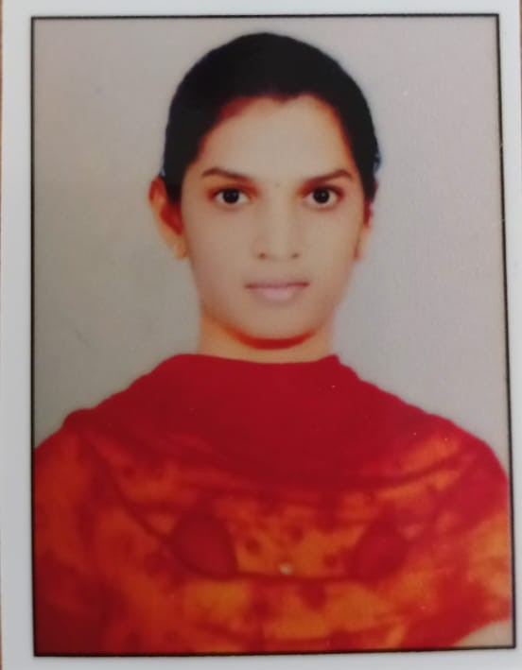

PHOTO

NAME: P.RENUKA

DATE OF BIRTH: 02-06-2001

DESIGNATION: ASSISTANT PROFESSOR

DEPARTMENT:AI&DS

EMAIL ID:PASUPULETIRENUKA805@GMAIL.COM

DATE OF JOINING:11-03-2024

EMPLOYEE ID:1762

## Academic Profile:

| **Qualification** | **Name of the Board/University** | **YEAR** |
| --- | --- | --- |
| **MCA** | **ANNAMACHARYA INSTITUTE OF TECHNOLOGY & SCIENCES,RAJAMPET** | **2023** |
| **B.Sc(MPC`S)** | **YOGIVEMANA UNIVERSITY,KADAPA** | **2021** |
| **INTERMEDIATE** | **SRI NALANDA JUNIOR COLLEGE,RAJAMPET** | **2018** |
| **SSC** | **Z.P.H.S NALLPUREDDYPALLI** | **2016** |

**Research Details:**

1. Areas of Specialization: COMPUTER APPLICATIONS
2. List of Publications:1
3. Awards Received : NIL
4. Research Guidance:
5. No. of PhD Guided: NIL
6. No. of M.Tech Guided: NIL
7. No. of B.Tech Guided: 2
8. Details of Professional Membership: NIL
9. Subjects Taught: BIG DATA ANALYTICS, CLOUD COMPUTING, C – PROGRAMMING, CRYPTOGRAPHY & NETWORK SECURITY, JAVA PROGRAMMING.

## Publication Details

|  |  |  |
| --- | --- | --- |
| **Title** | **Publisher** | **Published Year** |
| ADVANCED IMAGE GENERATION USING GENERATIVE ADVERSIAL NETWORKS(GANs):INNOVATIONS IN CREATING HIGH QUALITY SYNTHETIC IMAGES WITH AI | IEEE EXPLORE | 2025 |

## Patent Details

| **Sno.** | **Title of Patent** | **Submitted/Published/Awarded** |
| --- | --- | --- |