**ANNAMACHARYA UNIVERSITY FACULTY DETAILS FOR WEBSITE**

**About Profile**

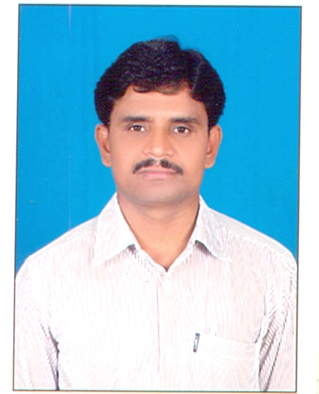

NAME: **Dr. B. Sreenivasulu**

DATE OF BIRTH: 06.01.1978

DESIGNATION: Assistant Professor

DEPARTMENT: Humanities and Sciences (Physics)

EMAIL ID: [**sreenu.physics@gmail.com**](mailto:sreenu.physics@gmail.com)

DATE OF JOINING: 03.08.2015

EMPLOYEE ID: AITS991025

## Academic Profile

| **Qualification** | **Name of the Board/University** | **YEAR** |
| --- | --- | --- |
| **Ph.D** | **S.V. University, Tirupathi** | **2018** |
| **M.Sc (Physics)** | **S.V. University, Tirupathi** | **2001** |
| **B.Sc** | **S.V. University, Tirupathi** | **1998** |

## Research Details

1. Areas of Specialization: Nano Materials
2. Number of Publications: 17
3. Awards Received : -
4. Research Guidance:
5. No. of PhD Guiding: -
6. No. of M.Tech Guided:-
7. No. of B.Tech Guided:
8. Subjects Taught:

* Engineering Physics
* Applied Physics
* Solid state Physics
* Environmental Science