**ANNAMACHARYA UNIVERSITY FACULTY DETAILS FOR WEBSITE**

**About Profile**

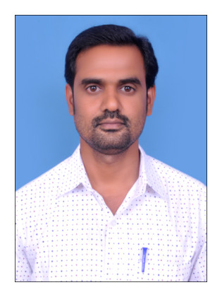

NAME: Dr. V. VISHNUVARDHAN

DATE OF BIRTH: 12-07-1981

DESIGNATION: Assistant Professor

DEPARTMENT: Humanities and Sciences

EMAIL ID: vishnuvardhan36369@gmail.com

DATE OF JOINING: 03-08-2015

EMPLOYEE ID: AITS991026

## Academic Profile

| **Qualification** | **Name of the Board/University** | **YEAR** |
| --- | --- | --- |
| **Ph.D** | **Sri Venkateswara University** | **2010** |
| **M.Phil** | **Sri Venkateswara University** | **2007** |
| **M.Sc** | **Sri Venkateswara University** | **2003** |

## Research Details

1. Areas of Specialization: Trace metal analysis
2. List of Publications:
3. Awards Received :
4. Research Guidance:
5. No. of PhD Guided:
6. No. of M.Tech Guided:
7. No. of B.Tech Guided:
8. Details of Professional Membership:
9. Subjects Taught: Environmental Science

## Publication Details

|  |  |  |
| --- | --- | --- |
| **Title** | **Publisher** | **Published Year** |
|  |  |  |

## Patent Details

| **Sno.** | **Title of Patent** | **Submitted/Published/Awarded** |
| --- | --- | --- |
|  |  |  |
|  |  |  |