**About Profile**

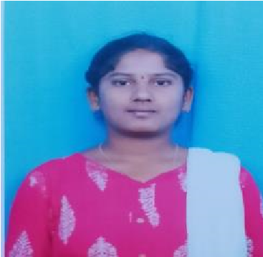

PHOTO

NAME: MUNDLA NANDINI

DATE OF BIRTH:23-06-2002

DESIGNATION: ASSISTANT PROFESSOR

DEPARTMENT:AI&DS

EMAIL ID: mundlanandini@gmail.com

DATE OF JOINING:03-10-2024

EMPLOYEE ID:2133

## Academic Profile

| **Qualification** | **Name of the Board/University** | **YEAR** |
| --- | --- | --- |
| **MCA(MASTER’S OF COMPUTER APPLICATION)** | **ANNAMACHARYA INSTITUTE OF TECHNOLOGY AND SCIENCES** | **2024** |
| **DEGREE** | **SV UNIVERSITY** | **2022** |
| **INTERMEDIATE** | **BOARD OF INTERMEDIATE EDUCATION** | **2019** |
| **SSC** | **BOARD OF SECONDARY EDUCATION** | **2017** |

## Research Details

1. Areas of Specialization:NIL
2. List of Publications:NIL
3. Awards Received :NIL
4. Research Guidance: NIL
5. No. of PhD Guided:NIL
6. No. of M.Tech Guided:NIL
7. No. of B.Tech Guided:NIL
8. Details of Professional Membership:NIL
9. Subjects Taught:NIL

## Publication Details

|  |  |  |
| --- | --- | --- |
| **Title** | **Publisher** | **Published Year** |
|  |  |  |

## Patent Details

| **Sno.** | **Title of Patent** | **Submitted/Published/Awarded** |
| --- | --- | --- |
|  |  |  |
|  |  |  |