**ANNAMACHARYA UNIVERSITY FACULTY DETAILS FOR WEBSITE**

**About Profile**

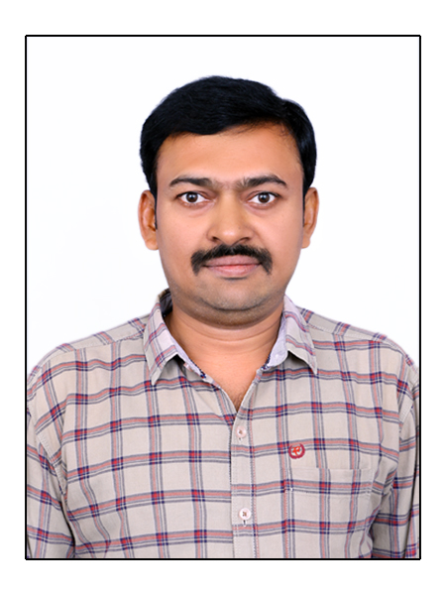

NAME: R. MAHESH KUMAR

DATE OF BIRTH: 24-08-1983

DESIGNATION: ASSISTANT PROFESSOR

DEPARTMENT: E.C.E.

EMAIL ID: rmahesh369786@gmail.com

DATE OF JOINING: 17-06-2004

EMPLOYEE ID: AITS041008

| **Qualification** | **Name of the Board/University** | **YEAR** |
| --- | --- | --- |
| Ph.D. | KL Deemed to be University,Guntur. | Pursuing |
| M.Tech. (VLSI DESIGN) | Sathyabama University, Chennai. | 2009-2011 |
| B.Tech.  ELECTRONICS  & INSTRUMENTATION ENGINEERING  (E.I.E) | JNT University,Hyderabad. | 2000-2004 |
| Intermediate  (M.P.C) | Board of Intermediate education,Andhra Pradesh. | 1998-2000 |
| S.S.C | Board of Secondary education,Andhra Pradesh. | 1997-1998 |

## Academic Profile

## Research Details

1. Areas of Specialization: VLSI DESIGN
2. List of Publications: 05
3. Awards Received : 00
4. Research Guidance:
5. No. of PhD Guided: 00
6. No. of M.Tech. Guided: 06
7. No. of B.Tech. Guided: 40
8. Details of Professional Membership:
9. Subjects Taught:

At UG Level:

* Electronic Measurements and Instrumentation
* Microprocessors and interfacing
* VLSI Design
* Linear IC Applications
* Analog IC Applications
* Electrical and electronic measurements
* Sensors and signal conditioning
* Industrial Instrumentation
* Industrial Electronics
* Analytical Instrumentation
* Power Plant Instrumentation
* PC Based Instrumentation
* Opto electronics and Laser Instrumentation
* Adaptive control systems
* Linear and Digital IC applications

At PG Level:

* Testing and Testability
* FPGA Architectures and Applications
* Low power VLSI Design

## Publication Details

|  |  |  |
| --- | --- | --- |
| **Title** | **Publisher** | **Published Year** |
| Home Automation Without Internet to run Electrical Devices | IEEE Explore | 2025 |
| Design and Simulation of Non-Inverting and Inverting Mixed Logic 2x4 Decoder Using Mentor Graphics 16nm Technology | Kalpa Publications in Computing. | 2024 |
| Design of Low-Power OTA for Bio-medical Applications | Springer Nature Singapore | 2023 |
| Design of Low Power, Low Noise Current Mirror OTA using 45nm Technology | Journal of Interdisciplinary Cycle Research | 2021 |
| Design and Implementation of AITS FM Radio | International Journal of Engineering Research | 2019 |