**ANNAMACHARYA UNIVERSITY FACULTY DETAILS FOR WEBSITE**

**About Profile**

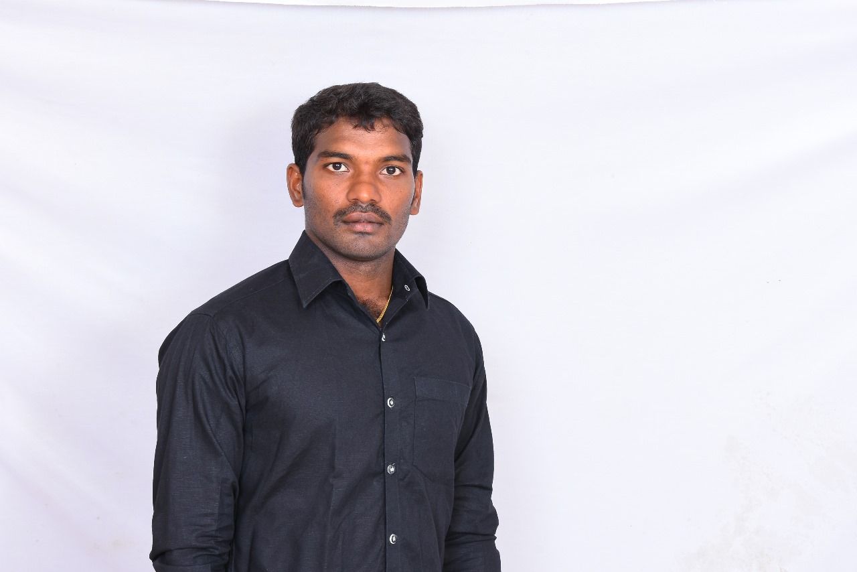

NAME: C.SRINIVASULU

DATE OF BIRTH: O1/02/1989

DESIGNATION:ASSISTANT PROFESSOR

DEPARTMENT:HUMANITIES AND SCIENCES

EMAIL ID:yellaiahsrinu@gmail.com

DATE OF JOINING:28/07/2015

EMPLOYEE ID:AITS991023

## Academic Profile

| **Qualification** | **Name of the Board/University** | **YEAR** |
| --- | --- | --- |
| **M.SC** | **S.V UNIVERSITY** | **2012** |
| **B.SC** | **S.V UNIVERSITY** | **2010** |
| **SSC** | **BOARD OF SECONDARY EDUCATION A.P** | **2007** |

## Research Details

1. Areas of Specialization:
2. List of Publications:
3. Awards Received :
4. Research Guidance:
5. No. of PhD Guided:
6. No. of M.Tech Guided:
7. No. of B.Tech Guided:
8. Details of Professional Membership:
9. Subjects Taught:

## Publication Details

|  |  |  |
| --- | --- | --- |
| **Title** | **Publisher** | **Published Year** |
|  |  |  |

## Patent Details

| **Sno.** | **Title of Patent** | **Submitted/Published/Awarded** |
| --- | --- | --- |
|  |  |  |
|  |  |  |