ANNAMACHARYA UNIVERSITY FACULTY DETAILS FOR WEBSITE

About Profile
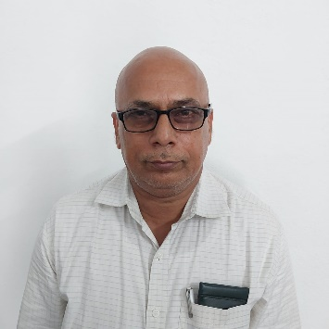

NAME : N. Veera Mohan Reddy

DATE OF BIRTH: 08/08/1964

DESIGNATION: Assistant Professor

DEPARTMENT: Humanities and Sciences

EMAIL ID:veeramohanreddyn@gmail.com

DATE OF JOINING:03/08/2015

EMPLOYEE ID: AITS991027

Academic Profile

Qualification | Name of the Board/University | YEAR
MSc | Nagapur university | 1989
BSc | SV University | 1986

Research Details
- Areas of Specialization: No
- List of Publications: 2
- Awards Received : Nil
- Research Guidance: Nil
- No. of PhD Guided: Nil
- No. of M.Tech Guided: Nil
- No. of B.Tech Guided: Nil

- Details of Professional Membership: Nil
- Subjects Taught: 1.Algebra and Calculus
2. Differential equations and vector calculus
3. Differential equations and Transform techniques
4. Probability and statistics
5. probability and complex variables
6. Complex variables and Transform techniques
7. Business Statistics
8. Numerical methods and Transform techniques
9. Matrix theory and calculus
10.Linear algebra and calculus

Publication Details

Title | Publisher | Published Year

Patent Details
Sno. | Title of Patent | Submitted/Published/Awarded

