**ANNAMACHARYA UNIVERSITY FACULTY DETAILS FOR WEBSITE**

**About Profile**

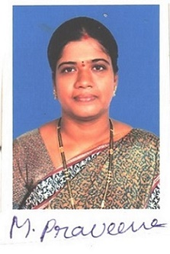

NAME: Dr.M.Praveena

DATE OF BIRTH: 04-08-1977

DESIGNATION: Assistant Professor

DEPARTMENT: Humanities & Sciences

EMAIL ID: prachen.2007@gmail.com

DATE OF JOINING: 01-09-2005

EMPLOYEE ID: AITS991005

## Academic Profile

| **Qualification** | **Name of the Board/University** | **YEAR** |
| --- | --- | --- |
| **PhD** | **Sri Padmavathi Mahila Viswa Vidyalayam** | **2020** |
| **M.Phli** | **Madirai Kamaraj University** | **2009** |
| **M.A** | **Sri Venkatesvara University** | **2004** |

## Research Details

1. Areas of Specialization:
2. List of Publications:
3. Awards Received :
4. Research Guidance:
5. No. of PhD Guided:
6. No. of M.Tech Guided:
7. No. of B.Tech Guided:
8. Details of Professional Membership:
9. Subjects Taught:

## Publication Details

|  |  |  |
| --- | --- | --- |
| **Title** | **Publisher** | **Published Year** |
|  |  |  |

## Patent Details

| **Sno.** | **Title of Patent** | **Submitted/Published/Awarded** |
| --- | --- | --- |
|  |  |  |
|  |  |  |