**ANNAMACHARYA UNIVERSITY FACULTY DETAILS FOR WEBSITE**

**About Profile**

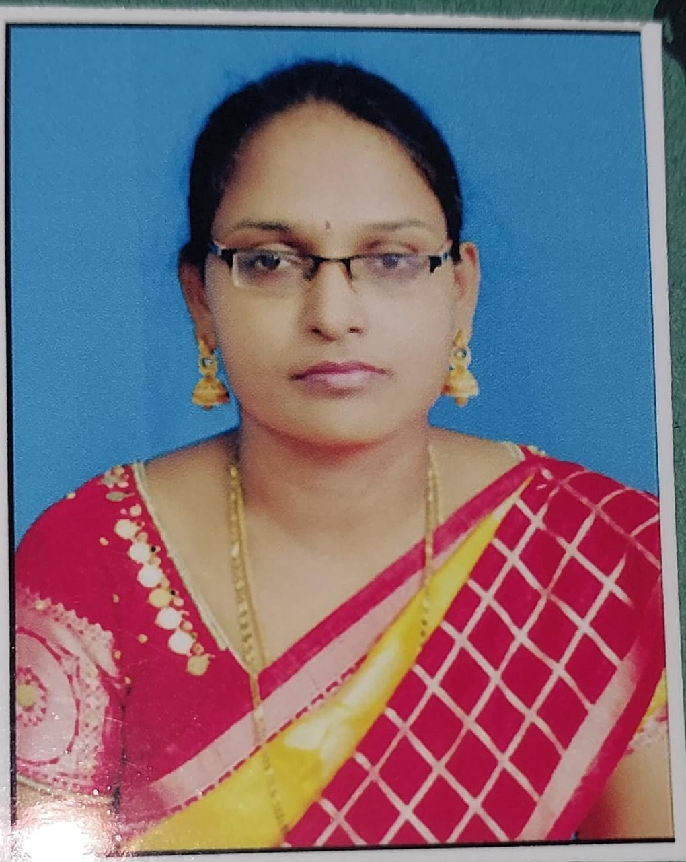

NAME: **Mrs Tejaswi Murarrysetty**

DATE OF BIRTH: **08-07-1985**

DESIGNATION: **Assistant Professor**

DEPARTMENT: **ECE**

EMAIL ID: **tejaswi.mt2530@gmail.com**

DATE OF JOINING: **20-12-2021**

EMPLOYEE ID:  **AITS041051**

## Academic Profile

| **Qualification** | **Name of the Board/University** | **YEAR** |
| --- | --- | --- |
| **M.Tech(DECS)** | **Annamacharya Institute of**  **Technology and Sciences, Rajampet (affiliated to JTNUA)** | **2012** |

## Research Details

1. Areas of Specialization: **M. Tech (DECS)**
2. List of Publications: **8**
3. Awards Received:
4. Research Guidance:
5. No. of PhD Guided:
6. No. of M. Tech Guided:
7. No. of B. Tech Guided: **5**
8. Details of Professional Membership: **IFERP**
9. Subjects Taught:

**Switching Theory and Logic Design,**

**Pulse and Digital Circuits.**

**Advanced Digital design Concepts,**

**Microprocessor and Interfacing.**

**Basic Electrical and Electronics Engineering**

**Electronic Devices and Circuits,**

**Communication systems**

**Digital logic design**

**Microwave Engineering**

**Digital Image Processing**

**Control system**

## Publication Details

|  |  |  |
| --- | --- | --- |
| **Title** | **Publisher** | **Published Year** |
| Minimization of image surface curvatures via image reconstruction using discrete mean and Gaussian curvature | **Springer** | 2025 |
| Speckle Reduction for the SAR Images Using an Improved Truncated Variational Method—Based Array | **Springer** | 2025 |
| Precise Detection of Vitiligo Using Deep Learning Methodology | **IEEE** | 2025 |
| Essential Security Features for developing a secure computer telecommunication Network | **UGC** | 2024 |
| DESIGN AND IMPLEMENTATION OF ALU USING GDI WITH CLOCK GATING TECHNIQUE | **UGC** | 2022 |
| Optimizing MRI Image Analysis for Brain Tumor Detection: A GLCM-Enabled U-Net Approach | **UGC** | 2022 |
| Additive White Gaussion Noise estimation in SVD Domain for single images | **UGC** | 2018 |
| Automatic Road and Vegetation Extraction Using High Resolution Satellite Images with an improving Accuracy | **UGC** | 2014 |

## Patent Details

| **Sno.** | **Title of Patent** | **Submitted/Published/Awarded** |
| --- | --- | --- |
|  |  |  |
|  |  |  |