**ANNAMACHARYA UNIVERSITY FACULTY DETAILS FOR WEBSITE**

**About Profile**

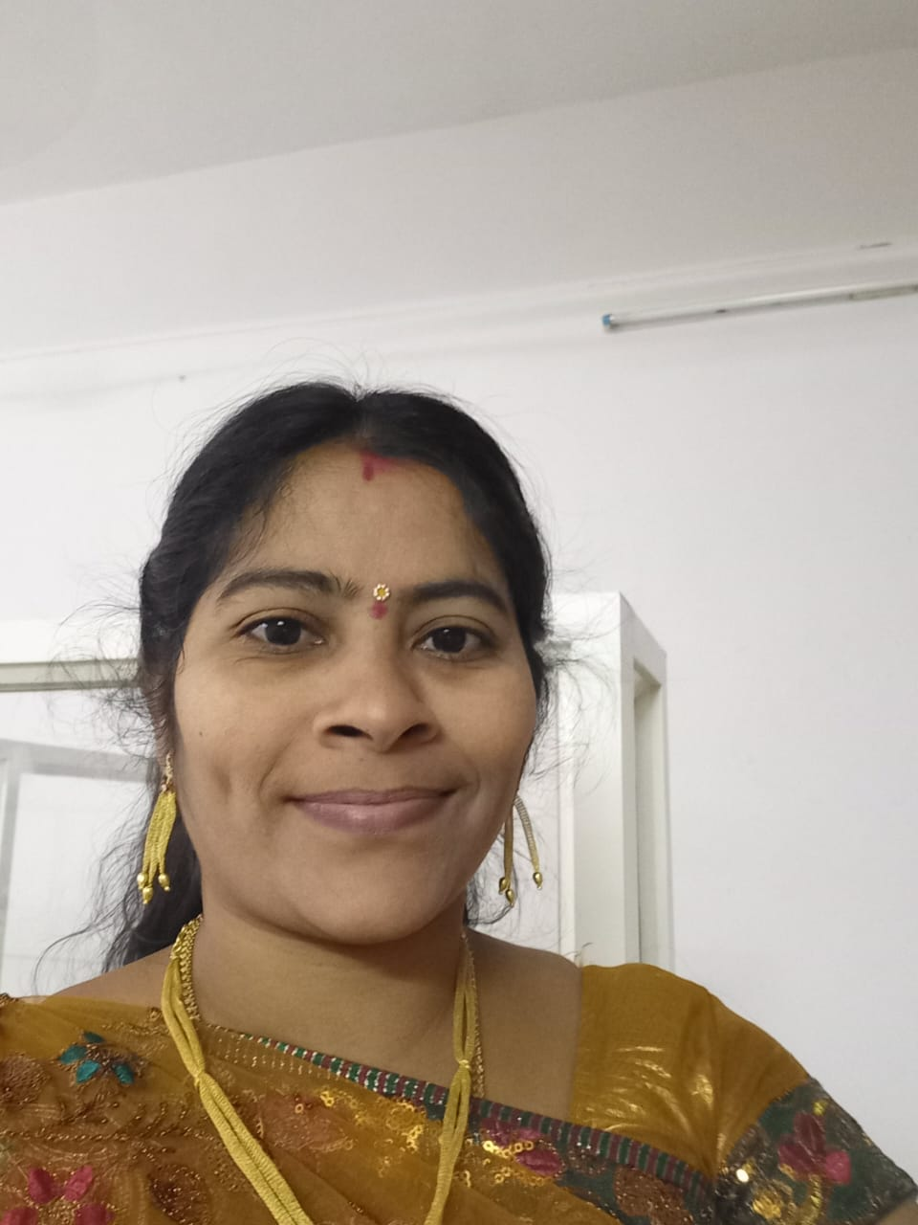

NAME: Y. SUNANDA

DATE OF BIRTH:02-06-1988

DESIGNATION: ASSISSTANT PROFESSOR

DEPARTMENT: ECE

EMAIL ID: aitssunanda@gmail.com

DATE OF JOINING:07-02-2002

EMPLOYEE ID: AITS041039

## Academic Profile

| **Qualification** | **Name of the Board/University** | **YEAR** |
| --- | --- | --- |
| **M.Tech** | **JNTUA, ANNATAPUR** | **2011** |
| **B. Tech** | **JNTUA, ANNATAPUR** | **2009** |
| **INTERMEDIATE** | **Board of Intermediate Education.** | **2005** |
| **S.S.C** | **Board of Secondary Education** | **2003** |

## Research Details

1. Areas of Specialization: VLSI Design
2. List of Publications:8
3. Awards Received:
4. Research Guidance:
5. No. of PhD Guided:
6. No. of M. Tech Guided:
7. No. of B. Tech Guided:15
8. Details of Professional Membership:
9. Subjects Taught: EDC, LICA, EMI, RADAR, MPI, MP&MC, VLSI

DESIGN, ADDC, VERILOG HDL PROGRAMMING,

FPGA ARCHITECTURES

## Publication Details

|  |  |  |
| --- | --- | --- |
| **Title** | **Publisher** | **Published Year** |
| Zigbee GPS Based Tracking System Using ARM 9 | International Journal of Electronics Communication and Computer Engineering | 2013 |
| ARM9 Based Navigation System for Vehicles | the **International Journal** of Engineering Sciences & Research Technology (IJESRT) | 2014 |
| Indoor localization Via Neural Networks and Wi-Fi Signal | Journal of Emerging Technologies and Innovative research | 2019 |
| Coordination Of Mobile Sensor For Target Tracking By Using Kalman Filter | IJFANS INTERNATIONAL JOURNAL OF FOOD AND NUTRITIONAL SCIENCES | 2022 |
| Morphology and EMD-Based Patch-Wise Image Fusion | Lecture Notes in Electrical Engineering | 2023 |
| Design and Implementation of Booth Multiplier with Skalsky and Ling Adder | Lecture Notes in Electrical Engineering, | 2024 |
| Enhanced Image Dehazing Using Contrast-Based Fusion Techniques | [Cognitive Science and Technology](https://www.springer.com/series/11554) | 2025 |
| **Asymmetrically Clipped Optical Orthogonal Frequency Division Multiplexing (ACO-OFDM) in Underwater Optical Communication** | [Cognitive Science and Technology](https://www.springer.com/series/11554) | 2025 |

## 

## Patent Details

| **Sno.** | **Title of Patent** | **Submitted/Published/Awarded** |
| --- | --- | --- |
|  |  |  |
|  |  |  |