**ANNAMACHARYA UNIVERSITY FACULTY DETAILS FOR WEBSITE**

**About Profile**

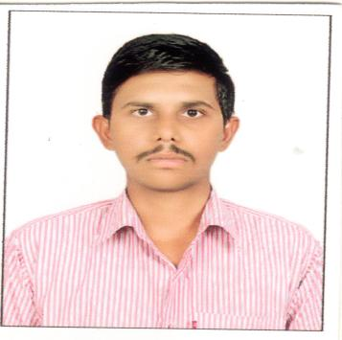

NAME: SHAIK MOHMMAD FAYAZ BASHA

DATE OF BIRTH: 03/04/1991

DESIGNATION: Assistant Professor

DEPARTMENT: ECE

EMAIL ID: fayazbasha440@gmail.com

DATE OF JOINING:28/09/2022

EMPLOYEE ID: AITS041659

## Academic Profile

| **Qualification** | **Name of the Board/University** | **YEAR** |
| --- | --- | --- |
| **M.TECH** | **R.G.M COLLEGE OF ENGINEERING AND TECHNOLOGY** | **2016** |
| **B.TECH** | **MADINA ENGINEERING COLLEGE** | **2012** |

## Research Details

1. Areas of Specialization: EMBEDDED SYSTEMS
2. List of Publications: 5
3. Awards Received :
4. Research Guidance:
5. No. of PhD Guided:
6. No. of M.Tech Guided:1
7. No. of B.Tech Guided:3
8. Details of Professional Membership: IAENG
9. Subjects Taught:

EMBEDDED SYSTEMS, COMMUNICATIONS SYSTEMS, BEEE, SATELLITE COMMUNICATIONS, DIGITAL SIGNAL PROCESSING, EMBEDDED SYSTEM DESIGN

## Publication Details

|  |  |  |
| --- | --- | --- |
| **Title** | **Publisher** | **Published Year** |
| Hyper Spectral Imagery System to Detect Endmember Sources | SPRINGER | 2024 |
| Multiband OFDM Uplink and Mixed Receiving in the Millimeter Wave | SPRINGER | 2024 |
| Beam Phenomenon in Dual-Polarized Antennas Using MIMO | SPRINGER | 2024 |
| Automated Glaucoma Detection and Classification via Deep Neural Networks and Feature Extraction | IEEE | 2024 |
| Optimizing MRI Image Analysis for Brain Tumor Detection: A GLCM-Enabled U-Net Approach | JOURNAL | 2022 |

## Patent Details

| **Sno.** | **Title of Patent** | **Submitted/Published/Awarded** |
| --- | --- | --- |
|  |  |  |
|  |  |  |