**ANNAMACHARYA UNIVERSITY FACULTY DETAILS FOR WEBSITE**

**About Profile**

NAME: **M.RUPA SREE**

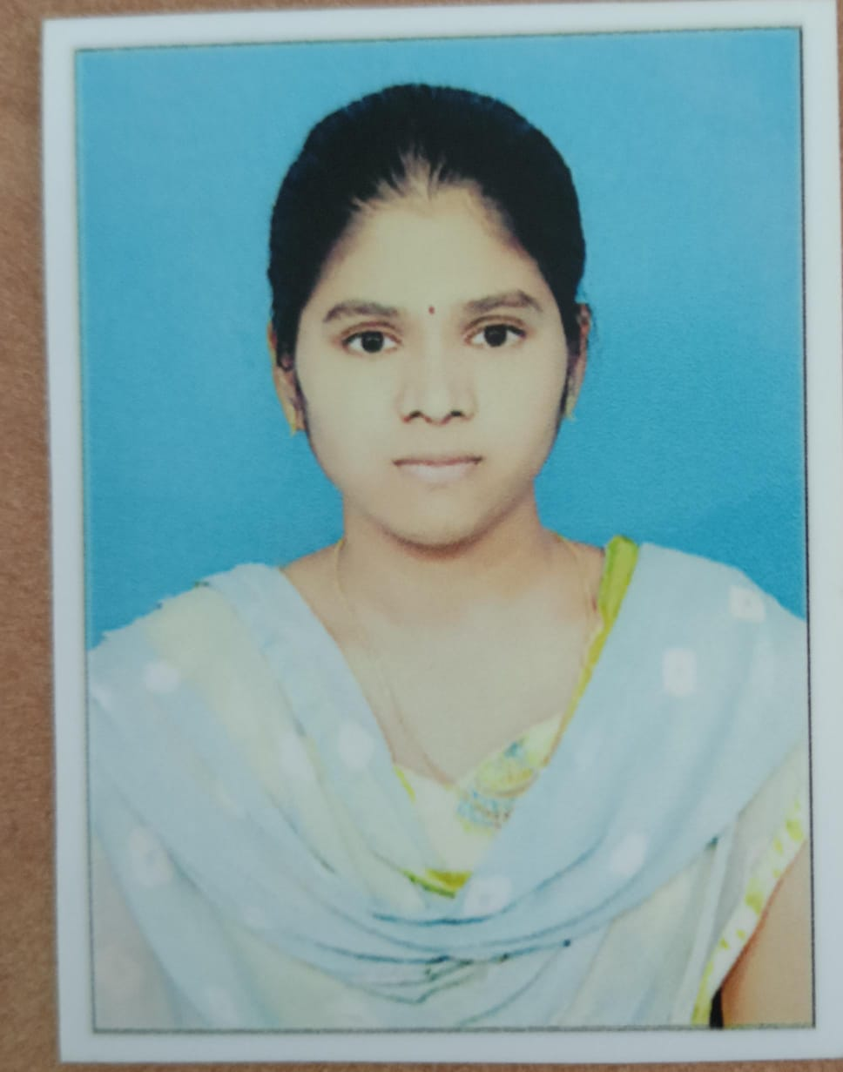

PHOTO

DATE OF BIRTH: **31-07-1998**

DESIGNATION: **Assistant Professor**

DEPARTMENT: **Humanities and Sciences (Physics)**

EMAIL ID: **rupasree51@gmail.com**

DATE OF JOINING: **15-11-2021**

EMPLOYEE ID: AITS991057

## Academic Profile

| **Qualification** | **Name of the Board/University** | **YEAR** |
| --- | --- | --- |
| M.Sc | Vikramasimhapuri univrsity | 2021 |
| B.Sc | Yogi vemana University | 2018 |
| Inter | Board of Intermediate | 2015 |
| SSC | Secondary Education Board | 2013 |

## Research Details

1. Areas of Specialization: **NIL**
2. List of Publications: **NIL**
3. Awards Received: **NIL**
4. Research Guidance: **NIL**
5. No. of PhD Guided: **NIL**
6. No. of M.Tech Guided: **NIL**
7. No. of B.Tech Guided: **NIL**
8. Details of Professional Membership: **NIL**
9. Subjects Taught: **Applied Physics**

## Publication Details

|  |  |  |
| --- | --- | --- |
| **Title** | **Publisher** | **Published Year** |
|  |  |  |
|  |  |  |

## Patent Details

| **Sno.** | **Title of Patent** | **Submitted/Published/Awarded** |
| --- | --- | --- |
|  |  |  |
|  |  |  |