**ANNAMACHARYA UNIVERSITY FACULTY DETAILS FOR WEBSITE**

**About Profile**

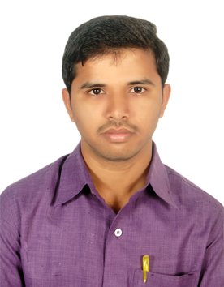

NAME :D Sivareddy

DATE OF BIRTH: 02/10/1993

DESIGNATION: Assistant Professor

DEPARTMENT: Humanities and Sciences

EMAIL ID:diddukuntasivareddy8@gmail.com

DATE OF JOINING:01/02/2022

EMPLOYEE ID: AITS991058

## Academic Profile

| **Qualification** | **Name of the Board/University** | **YEAR** |
| --- | --- | --- |
| **MSc** | **SK university** | **2013** |
| **BSc** | **SV University** | **2011** |

## Research Details

1. Areas of Specialization: No
2. List of Publications: Nil
3. Awards Received : Nil
4. Research Guidance: Nil
5. No. of PhD Guided: Nil
6. No. of M.Tech Guided: Nil
7. No. of B.Tech Guided: Nil
8. Details of Professional Membership: Nil
9. Subjects Taught: 1.Algebra and Calculus

2. Differential equations and vector calculus

3. Differential equations and Transform techniques

4. Probability and statistics

5. probability and complex variables

6. Complex variables and Transform techniques

7. Numerical methods and Transform techniques

8. Matrix theory and calculus

9.Linear algebra and calculus

10.Discrete Mathematics

## Publication Details

|  |  |  |
| --- | --- | --- |
| **Title** | **Publisher** | **Published Year** |
|  |  |  |

## Patent Details

| **Sno.** | **Title of Patent** | **Submitted/Published/Awarded** |
| --- | --- | --- |
|  |  |  |
|  |  |  |