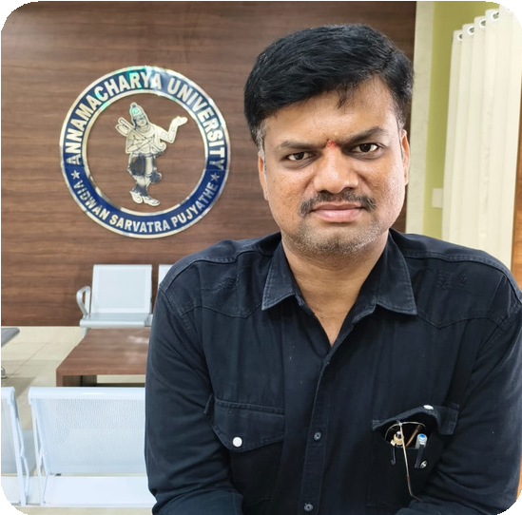

**K. DINESH VARMA**

**NAME : K Dinesh Varma**

**D.O.B : 30-08-1989**

**DESIGNATION : Asst Professor of Practice DEPARTMENT : Computer Science & Engineering EMAIL ID :** [**dvk@annamacharyauniversity.edu.in**](mailto:dvk@annamacharyauniversity.edu.in) **DATE OF JOINING : 24-09-2024**

**EMPLOYEE ID : AITS 05 1057**

Academic Profile

|  |  |  |
| --- | --- | --- |
| **Qualification** | **Name of the Board / University** | **Year** |
| **B.Tech** | **JNTU Ananthapur** | **2010** |
| **Intermediate** | **Board of Intermediate** | **2006** |
| **SSC** | **Board of Secondary School** | **2004** |

**Profile Summary :**

A seasoned professional with 14 years of rich industry experience, Iam certified expert in Microsoft tools and a PMP (Project Management Professional). With a strong background in project execution, process optimization, and technology integration, he brings a results- driven approach to every role. His deep understanding of industry practices and commitment to continuous improvement have consistently contributed to organizational growth and efficiency.

# Certifications

**Microsoft Certified (Tools & Applications) Project Management Professional (PMP)**

# Strengths

**Proven leadership in industry-driven projects Expertise in Microsoft platforms and productivity tools**

**Strong project management and stakeholder communication skills Focus on delivering quality outcomes within deadlines**