**ANNAMACHARYA UNIVERSITY FACULTY DETAILS FOR WEBSITE**

**About Profile**

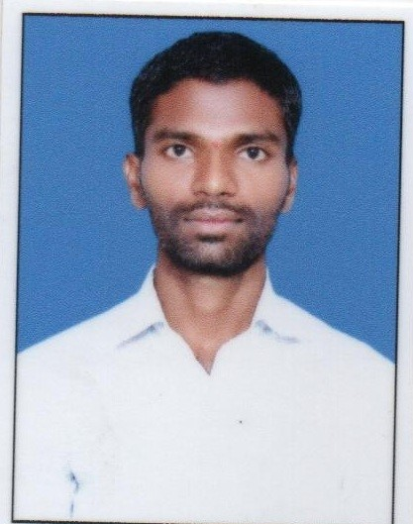

NAME: P. SUBRAMANYAM

DATE OF BIRTH: 15-05-1988

DESIGNATION: ASSISTANT PROFESSOR

DEPARTMENT: HUMANITIES AND SCIENCES

EMAIL ID: pulimi.subramanyam1988@gmail.com

DATE OF JOINING: 27-10-2022

EMPLOYEE ID: AITS991062

## Academic Profile

| **Qualification** | **Name of the Board/University** | **YEAR** |
| --- | --- | --- |
| **+2** | **Board of Intermediate Education** | **2005** |
| **B.Sc.** | **Sri Venkateswara University** | **2009** |
| **M.Sc.** | **Sri Venkateswara University** | **2011** |
| **B. Ed.** | **Yogi Vemana University** | **2012** |

## Research Details

1. Areas of Specialization: NIL
2. List of Publications: NIL
3. Awards Received: NIL
4. Research Guidance: NIL
5. No. of PhD Guided: NIL
6. No. of M.Tech Guided: NIL
7. No. of B.Tech Guided: NIL
8. Details of Professional Membership: NIL
9. Subjects Taught: Applied Physics, Engineering Physics

## Publication Details

|  |  |  |
| --- | --- | --- |
| **Title** | **Publisher** | **Published Year** |
|  |  |  |

## Patent Details

| **Sno.** | **Title of Patent** | **Submitted/Published/Awarded** |
| --- | --- | --- |
|  |  |  |
|  |  |  |