**ANNAMACHARYA UNIVERSITY FACULTY DETAILS FOR WEBSITE**

**About Profile**

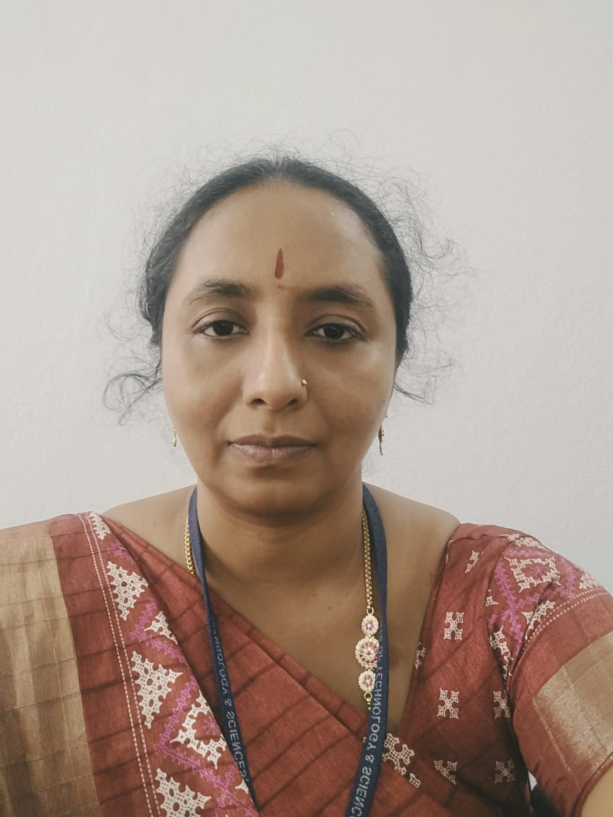

NAME: G V NARMATHA

DATE OF BIRTH: 15-4-1984

DESIGNATION: ASST.PROFESSOR

DEPARTMENT: H&S

EMAIL ID: narmatharaja1984@gmail.com

DATE OF JOINING: 1 -12-2022

EMPLOYEE ID: AITS991064

## Academic Profile

| **Qualification** | **Name of the Board/University** | **YEAR** |
| --- | --- | --- |
| **Ph.d** | **ANNAMACHARYA UNIVERSITY** | **PURSUING** |
| **MA(ENG)** | **SV UNIVERSITY** | **2019** |
| **B.ed** | **Y.V.UNIVERSITY** | **2022** |
| **B.COM(CA)** | **SV UNIVERSITY** | **2005** |
| **INTERMEDIATE(MPC)** | **BIE,AP** | **2002** |
| **SSC** | **BSE,AP** | **2000** |

## Research Details

1. Areas of Specialization:
2. List of Publications: 2
3. Awards Received :
4. Research Guidance:
5. No. of PhD Guided:
6. No. of M.Tech Guided:
7. No. of B.Tech Guided:
8. Details of Professional Membership:
9. Subjects Taught:

* English For Engineers,
* English Language Communication Skills,
* Professional Communication Lab,
* Communicative English

## Publication Details

|  |  |  |
| --- | --- | --- |
| **Title** | **Publisher** | **Published Year** |
|  |  |  |

## Patent Details

| **Sno.** | **Title of Patent** | **Submitted/Published/Awarded** |
| --- | --- | --- |
|  |  |  |
|  |  |  |