**ANNAMACHARYA UNIVERSITY FACULTY DETAILS FOR WEBSITE**

**About Profile**

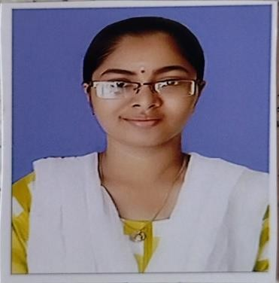NAME: BHEEMISETTY RENUKA DATE OF BIRTH: 13-07-2002 DESIGNATION: ASSISTANT PROFESSOR

DEPARTMENT: CSE

[EMAILID:renukabheemisetty@gmail.com](mailto:renukabheemisetty@gmail.com) DATE OF JOINING: 27-09-2024 EMPLOYEE ID: 2128

**Academic Profile**

|  |  |  |
| --- | --- | --- |
| **Qualification** | **Name of the Board/University** | **YEAR** |
| **MCA** | **SRI SAI COLLEGE OF IT AND MANAGEMENT,KADAPA** | **2024** |
| **DEGREE** | **SKM DEGREE COLLEGE,KADAPA** | **2022** |
| **INTERMEDIATE** | **BOARD OF INTERMEDIATE**  **EDUCATION** | **2019** |
| **SSC** | **BOARD OF SECONDARY**  **EDUCATION** | **2017** |

**Research Details**

1. Areas of Specialization:
2. List of Publications:
3. Awards Received :
4. Research Guidance:
   1. No. of PhD Guided:
   2. No. of M.Tech Guided:
   3. No. of B.Tech Guided:
5. Details of Professional Membership:
6. Subjects Taught:

**Publication Details**

|  |  |  |
| --- | --- | --- |
| **Title** | **Publisher** | **Published Year** |
|  |  |  |

**Patent Details**

|  |  |  |
| --- | --- | --- |
| **Sno.** | **Title of Patent** | **Submitted/Published/Awarded** |
|  |  |  |
|  |  |  |