**ANNAMACHARYA UNIVERSITY FACULTY DETAILS FOR WEBSITE**

**About Profile**

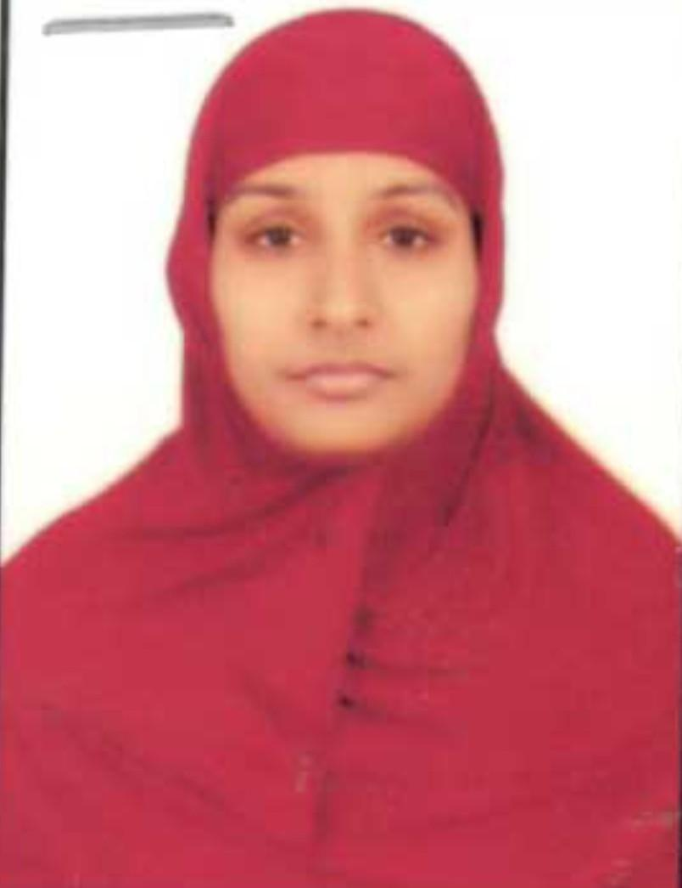

NAME:S.RESHMA

DATE OF BIRTH:15/08/1990

DESIGNATION:ASSISTANT PROFESSOR

DEPARTMENT:HUMANITIES AND SCIENCES

EMAIL ID:reshmabujji46@gmail.com

DATE OF JOINING:15/06/23

EMPLOYEE ID:AITS991068

## Academic Profile

| **Qualification** | **Name of the Board/University** | **YEAR** |
| --- | --- | --- |
| **B.ed** | **YOGIVEMANA UNIVERSITY** | **2014** |
| **MSC** | **JNTU,ANANTHAPUR** | **2012** |
| **B.SC** | **S.V UNIVERSITY** | **2010** |

## Research Details

1. Areas of Specialization:NIL
2. List of Publications:
3. Awards Received :NIL
4. Research Guidance:
5. No. of PhD Guided:
6. No. of M.Tech Guided:
7. No. of B.Tech Guided:
8. Details of Professional Membership:
9. Subjects Taught:CHEMISTRY

## Publication Details

|  |  |  |
| --- | --- | --- |
| **Title** | **Publisher** | **Published Year** |
|  |  |  |

## Patent Details

| **Sno.** | **Title of Patent** | **Submitted/Published/Awarded** |
| --- | --- | --- |
|  |  |  |
|  |  |  |