**ANNAMACHARYA UNIVERSITY FACULTY DETAILS FOR WEBSITE**

NAME:N. HARI CHANDANA

**About Profile**

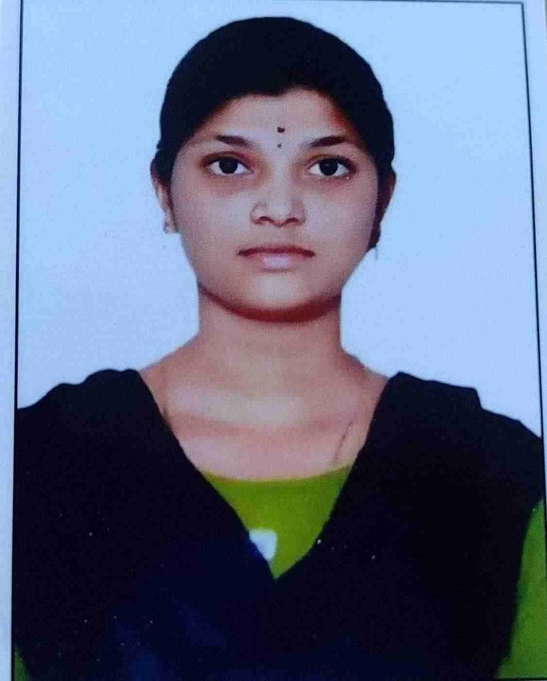

DATE OF BIRTH:10-05-2000

DESIGNATION:Assistant professor

DEPARTMENT:n Humanities and Sciences

EMAIL ID:harichandana.nakkala@gmail.com

DATE OF JOINING:16-06-2023

EMPLOYEE ID: AITS991069

|  |  |  |
| --- | --- | --- |
| **Qualification** | **Name of the Board/University** | **YEAR** |
| **M.A(ENGLISH)** | **YOGI VEMANA UNIVERSITY** | **2022** |
| **B.Sc** | **YOGI VEMANA UNIVERSITY** | **2020** |
| **INTERMEDIATE** | **BOARD OF INTERMEDIATE**  **EDUCATION** | **2017** |

**Academic Profile**

**Research Details**

1. Areas of Specialization:
2. List of Publications:
3. Awards Received :
4. Research Guidance:
   1. No. of PhD Guided:
   2. No. of M.Tech Guided:
   3. No. of B.Tech Guided:

1. Details of Professional Membership:

|  |  |  |
| --- | --- | --- |
| **Sno.** | **Title of Patent** | **Submitted/Published/Awarded** |
|  |  |  |
|  |  |  |

1. Subjects Taught:

**Publication Details**

|  |  |  |
| --- | --- | --- |
| **Title** | **Publisher** | **Published Year** |
|  |  |  |

**Patent Details**