**ANNAMACHARYA UNIVERSITY FACULTY DETAILS FOR WEBSITE**

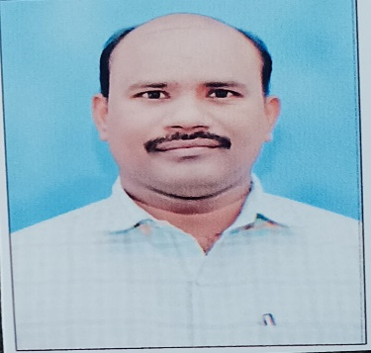**About Profile**

NAME: G Chinna Venkata Subbaiah

DATE OF BIRTH: 15-05-1987

DESIGNATION: ASSISTANT PROFESSOR

DEPARTMENT: HUMANITIES AND SCIENCES

EMAIL ID: drgcvsubbaiah@gmail.com

DATE OF JOINING: 19-06-2024

EMPLOYEE ID: 1778

## Academic Profile

| **Qualification** | **Name of the Board/University** | **YEAR** |
| --- | --- | --- |
| **(Ph.D.)-Physics** | **VIT-AP University** | **2025** |
| **MSC** | **YOGI VEMANA University** | **2011** |
| **BSC** | **S V University** | **2009** |