**ANNAMACHARYA UNIVERSITY FACULTY DETAILS FOR WEBSITE**

**About Profile**

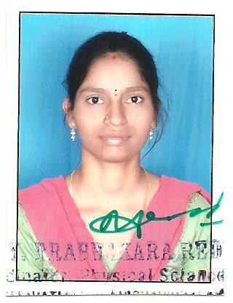

NAME: A. Vimala

DATE OF BIRTH: 16/06/1989

DESIGNATION: Assistant professor

DEPARTMENT: H&S

EMAIL ID: vimalaallam7@gmail.com

DATE OF JOINING: 19/06/2024

EMPLOYEE ID: 1779

## Academic Profile

| **Qualification** | **Name of the Board/University** | **YEAR** |
| --- | --- | --- |
| Ph.D (pursuing) | Vellore Institute of Technology, Vellore | 2019 (registered) |
| MSc | SPMVV, Tirupati | 2013 |
| BSc | SVU, Tirupati | 2009 |

## Research Details

1. Areas of Specialization: Pressure sensors
2. List of Publications: 2
3. Awards Received : 1
4. Research Guidance:
5. No. of PhD Guided:
6. No. of M.Tech Guided:
7. No. of B.Tech Guided:
8. Details of Professional Membership:
9. Subjects Taught:

## Publication Details

|  |  |  |
| --- | --- | --- |
| **Title** | **Publisher** | **Published Year** |
| Carbon black and boron nitride conductive fillers dispersed porous conductive polymer composite-based piezoresistive sensor for biomedical applications | Springer Nature | 2024 |

## Patent Details

| **Sno.** | **Title of Patent** | **Submitted/Published/Awarded** |
| --- | --- | --- |
|  |  |  |
|  |  |  |