**ANNAMACHARYA UNIVERSITY FACULTY DETAILS FOR WEBSITE**

**About Profile**

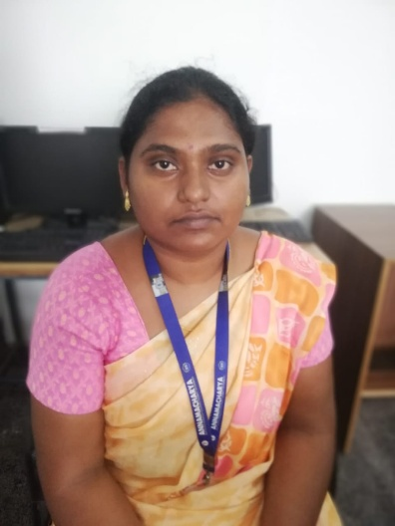

NAME: S. Bhargavi

DATE OF BIRTH: 29/06/1999

DESIGNATION: Assistant professor

DEPARTMENT: H&S

EMAIL ID: isbmathematician@gmail.com

DATE OF JOINING: 19/06/2024

EMPLOYEE ID: 1780

## Academic Profile

| **Qualification** | **Name of the Board/University** | **YEAR** |
| --- | --- | --- |
| MSc | SPMVV, Tirupati | 2021 |
| BA (MAS) | SVU, Tirupati | 2019 |
|  |  |  |

## Research Details

1. Areas of Specialization:
2. List of Publications:
3. Awards Received :
4. Research Guidance:
5. No. of PhD Guided:
6. No. of M.Tech Guided:
7. No. of B.Tech Guided:
8. Details of Professional Membership:
9. Subjects Taught:

## Publication Details

|  |  |  |
| --- | --- | --- |
| **Title** | **Publisher** | **Published Year** |
|  |  | 2024 |

## Patent Details

| **Sno.** | **Title of Patent** | **Submitted/Published/Awarded** |
| --- | --- | --- |
|  |  |  |
|  |  |  |