**ANNAMACHARYA UNIVERSITY FACULTY DETAILS FOR WEBSITE**

**About Profile**

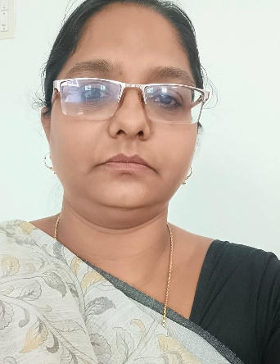

NAME: B. Sowjanya Swapna Priya

DATE OF BIRTH: 18/06/1981

DESIGNATION: Assistant professor of English

DEPARTMENT: H&S

EMAIL ID: soujishalem2019@gmail.com

DATE OF JOINING: 1/07/2024

EMPLOYEE ID: 1786

## Academic Profile

| **Qualification** | **Name of the Board/University** | **YEAR** |
| --- | --- | --- |
| M.E.D | Yogi Vemana University, Kadapa | 2011 |
| M.A (English) | Yogi Vemana University, Kadapa | 2021 |
| PGDELT | Regional Institute of English South India, Bangalore | 2022 |

## Research Details

1. Areas of Specialization:
2. List of Publications:
3. Awards Received :
4. Research Guidance:
5. No. of PhD Guided:
6. No. of M.Tech Guided:
7. No. of B.Tech Guided:
8. Details of Professional Membership:
9. Subjects Taught:

## Publication Details

|  |  |  |
| --- | --- | --- |
| **Title** | **Publisher** | **Published Year** |
|  |  | 2024 |

## Patent Details

| **Sno.** | **Title of Patent** | **Submitted/Published/Awarded** |
| --- | --- | --- |
|  |  |  |
|  |  |  |