**ANNAMACHARYA UNIVERSITY FACULTY DETAILS FOR WEBSITE**

**About Profile**

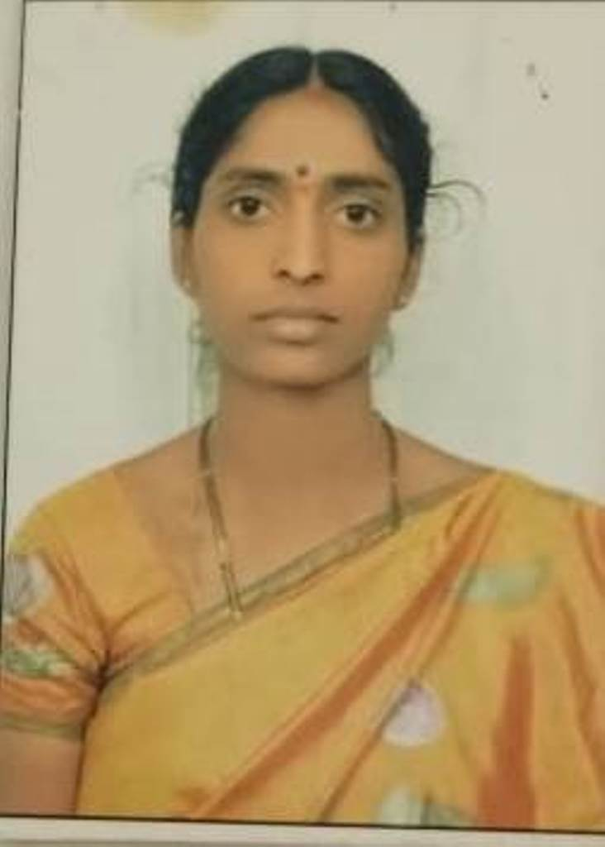

P

HOTO

NAME: Smt K Rajeswaramma

DATE OF BIRTH: 09-06-1984

DESIGNATION: Assistant Professor

DEPARTMENT: H&S (Mathematics)

EMAIL ID:vvnraji@gmail.com

DATE OF JOINING:15-07-2024

EMPLOYEE ID: 1793

## Academic Profile

| **Qualification** | **Name of the Board/University** | **YEAR** |
| --- | --- | --- |
| **M.Sc** | **Padmavati Mahila Visva Vidyalayam** | **2007** |
| **B.Sc** | **SV University** | **2005** |
| **SSC** | **ZPHS** | **2000** |

## Research Details

1. Areas of Specialization:
2. List of Publications:
3. Awards Received :
4. Research Guidance:
5. No. of PhD Guided:
6. No. of M.Tech Guided:
7. No. of B.Tech Guided:
8. Details of Professional Membership:
9. Subjects Taught:

## Publication Details

|  |  |  |
| --- | --- | --- |
| **Title** | **Publisher** | **Published Year** |
|  |  |  |

## Patent Details

| **Sno.** | **Title of Patent** | **Submitted/Published/Awarded** |
| --- | --- | --- |
|  |  |  |
|  |  |  |