**ANNAMACHARYA UNIVERSITY FACULTY DETAILS FOR WEBSITE**

**About Profile**

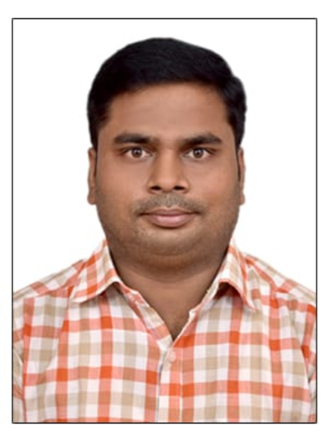

NAME: J PRASAD RAJU

DATE OF BIRTH: 24/07/1989

DESIGNATION: ASSISTANT PROFESSOR

DEPARTMENT: HUMANITIES AND SCIENCES

EMAIL ID: nanduprasad45350@gmail.com

DATE OF JOINING: 07/04/2025

EMPLOYEE ID: 2161

## Academic Profile

| **Qualification** | **Name of the Board/University** | **YEAR** |
| --- | --- | --- |
| **+2** | **Board of Intermediate Education** | **2006** |
| **B.Sc.** | **Sri Venkateshwara University** | **2009** |
| **M.Sc.** | **Sri Krishna devaraya University** | **2012** |
| **B.ed** | **Yogi Vemana University** | **2015** |
| **M.ed** | **Yogi Vemana University** | **2023** |
| **APSET** | **Andhra University** | **2019** |
|  |  |  |

## Research Details

1. Areas of Specialization: NIL
2. List of Publications: NIL
3. Awards Received: International Year of Chemistry – 2011 Activities
4. Research Guidance: NIL
5. No. of PhD Guided: NIL
6. No. of M.Tech Guided: NIL
7. No. of B.Tech Guided: NIL
8. Details of Professional Membership: NIL
9. Subjects Taught: Engineering Chemistry, Chemistry, Chemistry Lab

## Publication Details

|  |  |  |
| --- | --- | --- |
| **Title** | **Publisher** | **Published Year** |
|  |  |  |

## Patent Details

| **Sno.** | **Title of Patent** | **Submitted/Published/Awarded** |
| --- | --- | --- |
|  |  |  |
|  |  |  |