**ANNAMACHARYA UNIVERSITY FACULTY DETAILS FOR WEBSITE**

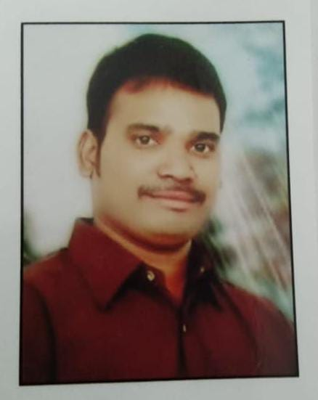**About Profile**

NAME: U. VINODKUMAR

DATE OF BIRTH:14-06-1989

DESIGNATION: ASSISTANT PROFESSOR

DEPARTMENT: HUMANITIES AND SCIENCES

EMAIL ID: [vinodkumarpn003@gmail.com](mailto:vinodkumarpn003@gmail.com)

DATE OF JOINING: 30-04-2025

EMPLOYEE ID: 2165

## Academic Profile

| **Qualification** | **Name of the Board/University** | **YEAR** |
| --- | --- | --- |
| **MSc** | **ACHARYA NAGARJUNA UNIVERSITY** | **2011** |
| **BSc** | **ACHARYA NAGARJUNA UNIVERSITY** | **2009** |
| **BEd** | **YOGIVEMANA UNIVERSITY** | **2022** |