**ANNAMACHARYA UNIVERSITY FACULTY DETAILS FOR WEBSITE**

**About Profile**

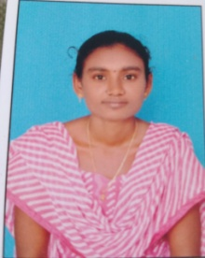

NAME: BANDI HARITHA

DATE OF BIRTH: 03/06/1992

DESIGNATION: ASSISTANT PROFESSOR

DEPARTMENT: Humanities and science

EMAIL ID: [harithabandi20@gmail.com](mailto:harithabandi20@gmail.com)

DATE OF JOINING: 30/04/2025

EMPLOYEE ID:2162

## Academic Profile

| **Qualification** | **Name of the Board/University** | **YEAR** |
| --- | --- | --- |
| **M.SC** | **YOGI VEMANA UNIVERISTY** | **2014** |
| **BSC (Computer Science)** | **S V UNIVERSITY** | **2012** |
| **INTER** | **Borad of intermidiate** | **2009** |

| SSC. Board of secondary Education 2007 |
| --- |

## Research Details

1. Areas of Specialization:
2. List of Publications:
3. Awards Received :
4. Research Guidance:
5. Details of Professional Membership:
6. Subjects Taught:,

,

## Publication Details

| **Title** | **Publisher** | **Published Year** |
| --- | --- | --- |
|  |  |  |

## Patent Details

| **Sno.** | **Title of Patent** | **Submitted/Published/Awarded** |
| --- | --- | --- |
|  |  |  |
|  |  |  |