**ANNAMACHARYA UNIVERSITY FACULTY DETAILS FOR WEBSITE**

**About Profile**

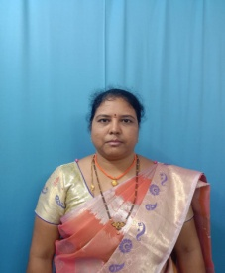

NAME: MANNERU HARITHA

PHOTO

DATE OF BIRTH: 08/05/1984

DESIGNATION: ASSISTANT PROFESSOR

DEPARTMENT: Humanities and science

EMAIL ID: harithamanneru123@gmail.com

DATE OF JOINING: 07/05/2025

EMPLOYEE ID:2168

## Academic Profile

| **Qualification** | **Name of the Board/University** | **YEAR** |
| --- | --- | --- |
| **M.SC** | **SRI KRISHNA DEVARAYA UNIVERSITY** | **2010** |
| **BSC (CPZ)** | **S V UNIVERSITY** | **2005** |
| **INTER** | **Borad of intermidiate** | **2001** |

| SSC. Board of secondary Education 1999 |
| --- |

## Research Details

1. Areas of Specialization:
2. List of Publications:
3. Awards Received :
4. Research Guidance:
5. No. of PhD Guided:
6. No. of M.Tech Guided:
7. No. of B.Tech Guided:
8. Details of Professional Membership:
9. Subjects Taught: Engineering chemistry,

Chemistry,

Environmental science,

Social ethics and values ,

Universal human values

## Publication Details

| **Title** | **Publisher** | **Published Year** |
| --- | --- | --- |
| Method of development and validation for the estimation of the tenofovir inpharmaceutial dosages form by spectrophotometric method | International journals of Research and Analytical Reviews E- ISSN: 2348-1269. P- ISSN: 2349-5138 | Sep 20 . 2022 |

## Patent Details

| **Sno.** | **Title of Patent** | **Submitted/Published/Awarded** |
| --- | --- | --- |
|  |  |  |
|  |  |  |