**ANNAMACHARYA UNIVERSITY FACULTY DETAILS FOR WEBSITE**

**About Profile**

NAME: Dr. S. Harinath Babu

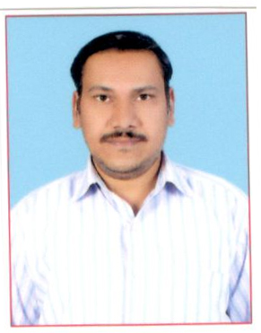

DATE OF BIRTH: 28-02-1977

DESIGNATION: Assistant Professor

DEPARTMENT: Humanities and Sciences (Physics)

EMAIL ID: shb@aitsrajampet.ac.in

DATE OF JOINING: 12-09-2012

EMPLOYEE ID: AITS991015

## Academic Profile

| **Qualification** | **Name of the Board/University** | **YEAR** |
| --- | --- | --- |
| **Ph.D (Physics)** | **V.I.T. University, Vellore, T.N** | **2016** |
| **M.Tech (Energy Management)** | **S. V. University, Tirupathi** | **2004** |
| **M. Sc.(Tech) (Physics)** | **Jawaharlal Nehru Technological University.** | **2001** |

## Research Details

1. Areas of Specialization:
2. List of Publications:
3. Awards Received :
4. Research Guidance:
5. No. of PhD Guided:
6. No. of M.Tech Guided:
7. No. of B.Tech Guided:
8. Details of Professional Membership:
9. Subjects Taught:

## Publication Details

|  |  |  |
| --- | --- | --- |
| **Title** | **Publisher** | **Published Year** |
|  |  |  |

## Patent Details

| **Sno.** | **Title of Patent** | **Submitted/Published/Awarded** |
| --- | --- | --- |
|  |  |  |
|  |  |  |