**About Profile**

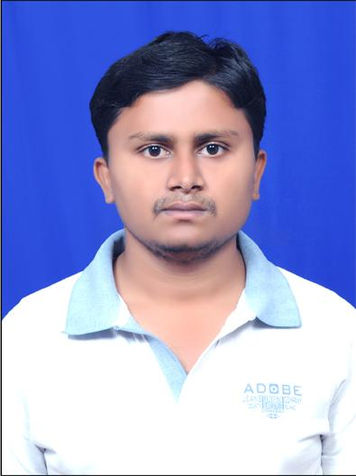

NAME:URAMALA NARESH KUMAR

DATE OF BIRTH:31/03/1994

DESIGNATION: Asst.professor

DEPARTMENT: Artificial Intelligence and Data Science

EMAIL ID:naresh.u506@gmail.com

DATE OF JOINING: 01/09/2023

EMPLOYEE ID:1728

## Academic Profile

| **Qualification** | **Name of the Board/University** | **YEAR** |
| --- | --- | --- |
| **Ph.d** | **GIET UNIVERSITY** | **PURSUING** |
| **M.Tech** | **JNTUA,ANANTHAPUR** | **2023** |
| **B.Tech** | **JNTUA,ANANTHAPUR** | **2017** |
| **INTER** | **STATE BOARD** | **2012** |
| **SSC** | **STATE BOARD** | **2010** |

## Research Details

1. Areas of Specialization: MACHINE LEARNING
2. List of Publications:01
3. Awards Received : NIL
4. Research Guidance:
5. No. of PhD Guided: NIL
6. No. of M.Tech Guided: NIL
7. No. of B.Tech Guided:02
8. Details of Professional Membership: NIL
9. Subjects Taught: C PROGRAMMING

DATA STRUCTURES USING C

DATA BASE MANAGEMENT SYSTEMS

OBJECT ORIENTED PROGRAMMING LANGUAGE USING JAVA

PRINCIPLES OF ARTIFICIAL INTELLIGENCE

## Publication Details

|  |  |  |
| --- | --- | --- |
| **Title** | **Publisher** | **Published Year** |
| PREDICTING CROPS BASED ON SOIL AND ENVIRONMENT CHARACTERSTICS USING ARIMA AND LSTM MODEL | 4TH IEEE INTERNATIONAL COFERENCE ON MOBILE NETWORKS AND WIRELESS COMMUNICATIONS(ICMNWC-2024) | DECEMBER 2024 |

## Patent Details

| **Sno.** | **Title of Patent** | **Submitted/Published/Awarded** |
| --- | --- | --- |
|  |  |  |
|  |  |  |