

NAME:Shaik Tabassum DATE OF BIRTH:18/7/97

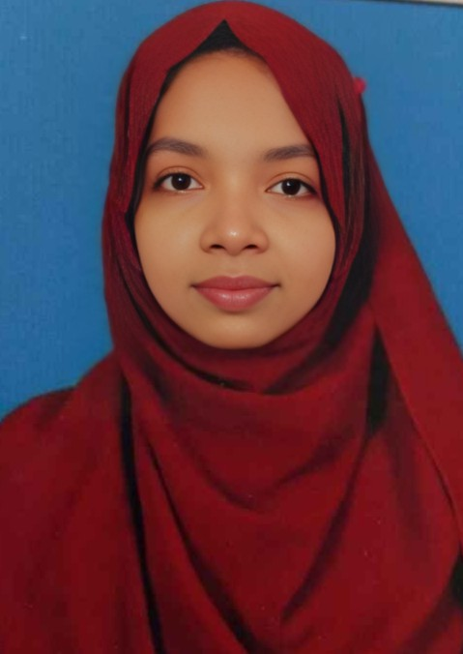

DESIGNATION: Assistant professor DEPARTMENT:CSE

EMAIL ID: [tabassums@aitsrajampet.ac.in](mailto:tabassums@aitsrajampet.ac.in) DATE OF JOINING:8/9/2022

EMPLOYEE ID:1653



|  |  |  |
| --- | --- | --- |
|  |  |  |
|  |  |  |
|  |  |  |
|  |  |  |



1. Areas of Specialization:
2. List of Publications:1
3. Awards Received :
4. Research Guidance: 1
   1. No. of PhD Guided:
   2. No. of M.Tech Guided:
   3. No. of B.Tech Guided:2
5. Details of Professional Membership:
6. Subjects Taught: python,java , software engineering



|  |  |  |  |  |  |
| --- | --- | --- | --- | --- | --- |
|  | |  | |  | |
| Data sharing |  | IMSTEM-2025 |  | 2025 |  |
| protocol to minimise cloud storage security in  big data era | |  | |  | |



|  |  |  |
| --- | --- | --- |
|  |  |  |
|  |  |  |
|  |  |  |