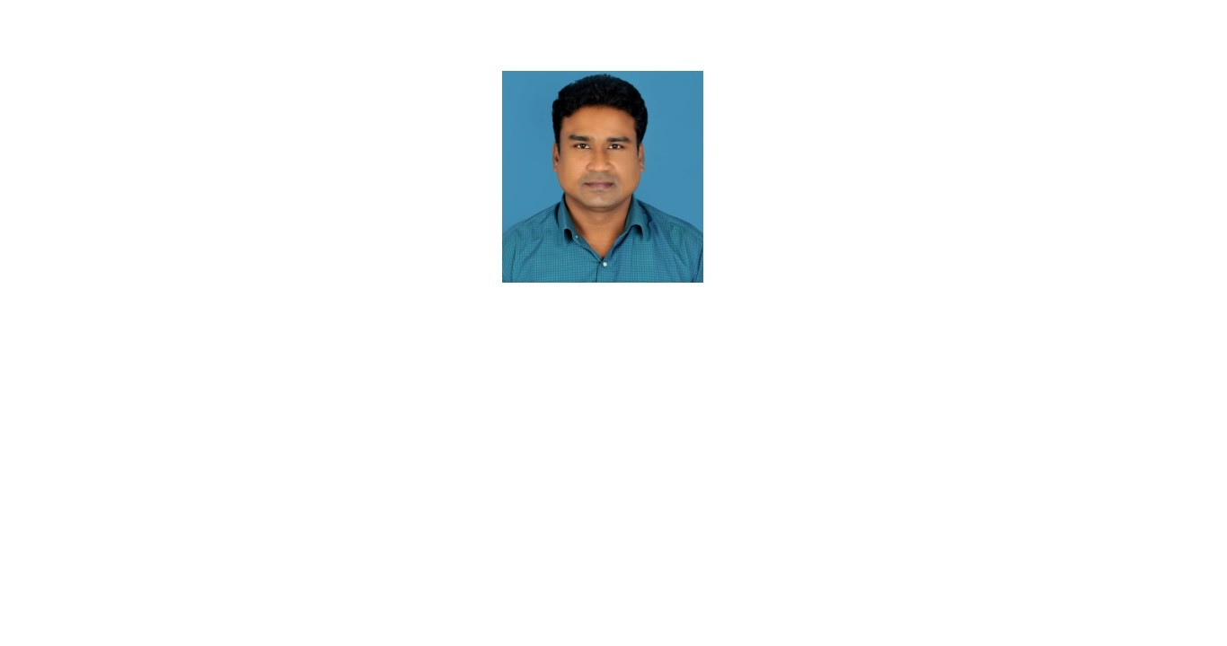

# Dr Nagadasari Merrin Prasanna

E-mail: [nagadasari.merrin@gmail.com](mailto:nagadasari.merrin@gmail.com)

Profile URL : [https://vidwan.inflibnet.ac.in//profile/292279](https://vidwan.inflibnet.ac.in/profile/292279)

Orcid Id: 0000-0002-6905-8652

Phone: 8328578077, 8374113218

Address: Badvel ,Andhra Pradesh,India - 516227

# Expertise

## Telecommunications

Signal and Image Processing,Soft Computing techniques

# Work experience

## Annamcharya University 2022 — Present

#### Associate Professor

Annamayya District

## Annamacharya Institute of Technology and Sciences 2022 — 2022

#### Associate Professor

Kadapa

## Annamcharya University 2022 — 2022

#### Associate Professor

Annamayya District

# Education

## Ph.D - 2021

Koneru Lakshmaiah Education Foundation



# Honours and Awards

## Emerging Scientist - 2019

Texas Instruments

# Research Project

## Camera based temperature monitoring system using digital image processing

Role: Research Scholar Year 2018, Amount 100000

# Membership In Professional Bodies

1. IEEE,ISTE,IFERP, 2021

Permanent

# Membership In Committees

Patent

### “COMPUTER IMPLEMENTED METHOD AND SYSTEM FOR PROCESSING QUALITATIVE IMAGING TO DETECT AND FORECAST ABNORMALITIES”

Inventor(s): N.Merrin Prasanna, Assignee:

Published: 0000-00-00

### optimal hybrid approach for avoiding trains collisions

Inventor(s): N.Merrin Prasanna, Assignee: N.Merrin Prasanna

Published: 2024-04-12



# Publication

### Enhanced Brain Stroke Detection Using Optimized MobileNet, DenseNet, and ResNet Architectures

Daggolla Ramachandra, N.Merrin Prasanna, D.Subhash Chandra Mouli, Majjari Sudhakar, Katuri Keerthi Naidu, K.Riyazuddin

ICICDS 2025, Volume , Year 2025, Pages

### Effective Minimization of Fraud Using a Hybrid Novel Approach on Social Media

N.Merrin Prasanna;Vijaya Chandra Jadala;S.Hrushikesava Raju;Nabanita Choudhury;S. Adinarayna;VV Jaya rama Krishnaiah

2025 4th International Conference on Sentiment Analysis and Deep Learning (ICSADL), Volume , Year 2025, Pages 76-84

### An Enhanced Woelfel Image Noise Filter

Riyazuddin K.;Bajidvali S.;Raheem B.A.;Karimullah S.;Merrin Prasanna N.;Swathi P. Studies in Computational Intelligence, Volume 1117, Year 2024, Pages 71-80

### Design and Development of Leaf Disease Detection Using the ML and Open CV for Tomato Plants

N. Merrin Prasanna;Ch. Nagarau;C. Venkatesh;D. Subash Chandra Mouli;K. Riyazuddin;B. Rakesh Babu Lecture Notes in Electrical Engineering, Volume 1096, Year 2024, Pages 33-43

### Novel Efficient Approach that Enhances Security over Biometric Systems Using Computer Vision Techniques

S. Hrushikesava Raju;Shaik Jumlesha;Uruturu Sesadri;Ashok Koujalagi;Adinarayana Salina;N. Merrin Prasanna

Leveraging Computer Vision to Biometric Applications, Volume , Year 2024, Pages 198-211

### Intelligent Tool Wear Monitoring: A Confluence of Improved Dragonfly Optimization and Deep Belief Networks

Hrushikesava Raju S.;Adinarayna S.;Koujalagi A.;Merrin Prasanna N.;Jumlesha S.;Sesadri U. Smart Innovation Systems and Technologies, Volume 395 SIST, Year 2024, Pages 515-527

### Novel Efficient Approach that Enhances Security over Biometric Systems Using Computer Vision Techniques

S. Hrushikesava Raju, Shaik Jumlesha, Uruturu Sesadri, Ashok Koujalagi, Adinarayana Salina, N. Merrin Prasanna

Leveraging Computer Vision to Biometric Applications, Volume , Year 2024, Pages

### Tomato Leaves Disease Identification by Deep Convolution Neural Network Using Inception V3

Devi D.;Prasanna N.;Ram R.A.S.P.;Mohamed N.N.



Aip Conference Proceedings, Volume 2914, Year 2023

### Machine Learning Based Smart Helmet for Air Quality and Hazardous Event Detection in the Mining Industry

Devi, D. , Prasanna, N. , Ram, R.A.P. , Mohamed, N.N.

International Conference on Self Sustainable Artificial Intelligence Systems Icssas 2023 Proceedings, Volume , Year 2023, Pages 1790-1795

### Accurate Brain Disease Diagnosis with UE-CNN Uncertainty Discrimination

Raju S.H.;Adinarayna S.;Prasanna N.M.;Jumlesha S.;Sesadri U.;Nandini V.

7th International Conference on Electronics Communication and Aerospace Technology Iceca 2023 Proceedings, Volume , Year 2023, Pages 603-612

### Accurate Brain Disease Diagnosis with UE-CNN Uncertainty Discrimination

S. Hrushikesava Raju;S. Adinarayna;N. Merrin Prasanna;Shaik Jumlesha;U. Sesadri;V. Nandini

2023 7th International Conference on Electronics, Communication and Aerospace Technology (ICECA), Volume , Year 2023, Pages 603-612

### Machine Learning Based Automated Disaster Message Classification System Using Linear SVC Algorithm

International Conference on Intelligent Cyber Physical Systems and Internet of Things ICoICI 2022, Year 2023

### (Digital Presentation) Design and Development of Leaf Disease Detection Using the ML and Open CV for Tomato Plants

ECS Meeting Abstracts, Year 2023

### Nutrient Deficiency Detection using a MobileNet: An AI-based Solution

Raju S.H.;Adinarayna S.;Prasanna N.M.;Jumlesha S.;Sesadri U.;Hema C.

7th International Conference on I Smac Iot in Social Mobile Analytics and Cloud I Smac 2023 Proceedings, Volume , Year 2023, Pages 609-615

### Keen Energy Efficient Street Light Controlling Framework Dependent on IoT for Smart Campus MRRITS

Malapati M.;Merrin Prasanna N.;Akula N.;Policherla R.;Chejarla S.K.;Lekkala D. Lecture Notes in Electrical Engineering, Volume 783, Year 2022, Pages 1467-1477

### Industrial IoT Enabled Fuzzy Logic Based Flame Image Processing for Rotary Kiln Control

Nagadasari M.P.;Bojja P.

Wireless Personal Communications, Volume 125, Year 2022, Pages 2647-2665

### Keen Energy Efficient Street Light Controlling Framework Dependent on IoT for Smart Campus MRRITS

Lecture Notes in Electrical Engineering, Year 2022

### Design and Development of leaf disease detection using the ML and Open CV for Tomato plants

N. MerrinPrasanna



2022 IEEE Pune Section International Conference, Volume , Year 2022, Pages

### Machine learning based automated disaster message classification system using linear SVC algorithm

N.Merrin Prasanna,S.Raja Mohan,K.Vishnu Vardhan Reddy,B.Sai Kumar,C.Guru Babu,P.Priya International conference on intelligent cyber physical systems and internet of things(ICoICI 2022), Volume , Year 2022, Pages

### Development of Conventional Controller Based on Image Processing for Monitoring and Controlling Burning Zone Temperature in a Cement Plant in Rotary Kiln Process Through IOT.

Polaiah Bojja1* , N. Merrin Prasanna2 , Pamula Raja Kumari3 , T. Bhuvanendhiran4 , Panuganti Jayanth Kumar1

Instrumentation, Mesures, Métrologies , Volume 20(4), Year 2021, Pages 209-214

### smart intelligent drone for painting using IoT:AN automated approach for efficient painting

N.Merrin Prasanna

IEEE conference, Volume , Year 2021, Pages

### Smart Covid simulation App for tracking of area-wise COVID patients:Making aware of number of patients while moving on the places

N.Merrin Prasanna

IEEE conference, Volume , Year 2021, Pages

### Fully Smart fire detection and prevention in the authorized forests

Karumanchi V.R.;Raju S.H.;Kavitha S.;Lakshmi Lalitha V.;Vijaya Krishna S.

2021 International Conference on Artificial Intelligence and Smart Systems (ICAIS), Volume , Year 2021, Pages 573-579

### Industrial IoT enabled fuzzy logic based flame image processing for rotary kiln control

Nagadasari M.P.;Bojja P.

International Journal of Pervasive Computing and Communications, Volume 17, Year 2021, Pages 533-548

### Development of conventional controller based on image processing for monitoring and controlling burning zone temperature in a cement plant in rotary kiln process through iot

Bojja P.;Merrin Prasanna N.;Kumari P.R.;Bhuvanendhiran T.;Kumar P.J. Instrumentation Mesure Metrologie, Volume 20, Year 2021, Pages 209-214

### Industrial IoT enabled fuzzy logic based flame image processing for rotary kiln control

International Journal of Pervasive Computing and Communications, Year 2021

### Design and real time implementation of Anfis controller for optimizing the burning zone temperature in rotary kiln in cement industry

N. MERRIN PRASANNA AND POLAIAH BOJJA



The Journal of Research on the Lepidoptera, Volume 51(2), Year 2020, Pages 480-498

### Keen Energy Efficient Street Light Controlling Framework Dependent on IoT for Smart Campus MRRITS

M Malapati, N Merrin Prasanna, N Akula, R Policherla, SK Chejarla ICDSMLA 2020, Volume , Year 2020, Pages 1467-1477

### RADAR BASED ANIMAL DETECTION SYSTEM FOR ROAD SAFETY

N. MerrinPrasanna

Journal of Xi'an University of Architecture & Technology, Volume , Year 2020, Pages 1695-1700

### Development of mathematical model based roi for rotary kiln to measure burning zone temperature in cement industry by digital image processing

International Journal of Control and Automation, Year 2020

### Classification of food categories and ingredients approximation using an fd-mobilenet and TF-Yolo

International Journal of Advanced Science and Technology, Year 2020

### Development of mathematical model based roi for rotary kiln to measure burning zone temperature in cement industry by digital image processing

Merrin Prasanna N.;Bojja P.

International Journal of Control and Automation, Volume 13, Year 2020, Pages 416-427

### Classification of food categories and ingredients approximation using an fd-mobilenet and TF-Yolo

Merrin Prasanna N.;Subash Chandra Mouli D.;Sireesha G.;Priyanka K.;Radha D.;Manmadha B. International Journal of Advanced Science and Technology, Volume 29, Year 2020, Pages 3104-3114

### Classification of Food categories and Ingredients approximation using an FDMobilenet and TF‐YOLO

N.Merrin Prasanna,D.S.C .Mouli,B.Radha,

International Journal of Advanced Science and Technology, Volume 29(6), Year 2020, Pages 3104-3114

### titled.”WIRELESS CHARGING OF MOBILES BY USING MICROWAVES”

N Merrin Prasanna,D.S.C.Mouli

“Recent Advances in Technology & Engineering (CRATE-2020)”, Volume , Year 2020, Pages

### Optimization of Rotary Kiln in Cement Industry Using Conventional Control Systems

N. MerrinPrasanna,PB

Helix The scientific explorer , Volume 9(1), Year 2019, Pages 4843-4849

### “COMPUTER IMPLEMENTED METHOD AND SYSTEM FOR PROCESSING QUALITATIVE IMAGING TO DETECT AND FORECAST ABNORMALITIES”,

NM Prasanna

IN Patent 38/2,019, Volume , Year 2019, Pages

### Development and evaluation of mathematical model based region of interest for rotary kiln burning zone temperature in cement industry by digital image processing



N Merrin Prasanna, Polaiah Bojja

International journal of innovative technology and exploring engineering, Volume 8(9), Year 2019, Pages 3200-3208

### Development of mathematical model of rotary kiln which are used for design conventional control systems

International Journal of Engineering and Technology(UAE), Year 2018

### Development of Mathematical Model of Rotary Kiln which are used for Design Conventional Control Systems

Polaiah Bojja, N. Merrin Prasanna , Pamula Raja kumari

International Journal of Engineering & Technology, Volume 7(3.12), Year 2018, Pages 1182-1186

### Development of mathematical model of rotary kiln which are used for design conventional control systems

Bojja P.;Prasanna N.M.;kumari P.R.

International Journal of Engineering and Technology Uae, Volume 7, Year 2018, Pages 1182-1186

### Computational intelligence survey analysis for advanced modeling and development of intelligent controller based on wireless sensor networks for industrial application

Journal of Advanced Research in Dynamical and Control Systems, Year 2017

### Computational intelligence survey analysis for advanced modeling and development of intelligent controller based on wireless sensor networks for industrial application

MerrinPrasanna N.;Bojja P.

Journal of Advanced Research in Dynamical and Control Systems, Volume 9, Year 2017, Pages 264-280

### Design and Analysis of UWB Antenna for Wireless Commercial Applications

N. MerrinPrasanna,Sowjanya B,V IJAEM, Volume 5(3), Year 2016, Pages

### An Efficient High Performance Wallace Tree Multiplier Using Modified Booth Encoder Design and Implementation

N. Merrin Prasanna,Sowjanya B.V

INTERNATIONAL JOURNAL OF APPLIED SCIENCES, ENGINEERING AND MANAGEMENT, Volume 5(3), Year

2016, Pages

### Performance analysis of dual hop relaying over Rayleigh fading channels

Patteti K.;Tipparti A.K.;Kalitkar K.R.;Kanapala S.;Prasanna N.M.

IFIP International Conference on Wireless and Optical Communications Networks Wocn, Volume 2016- November, Year 2016

### 'Design and Development of Leaf Disease Detection Using the ML and



Open CV for Tomato Plants '

'Merrin Prasanna, N. Nagarau, Ch. Venkatesh, C. Subash Chandra Mouli, D. Riyazuddin, K. Rakesh Babu,

B. '

, Year 0, Pages '33--43 '

Downloaded from [Vidwan](https://vidwan.inflibnet.ac.in/) : Expert Database & National Researcher's Network <https://vidwan.inflibnet.ac.in/>